

ITWB2914 Minor Project
Report

Name : Kaviarasan A/L Vijayakumar
Matric Number : MC230120817
Supervisor : Dr Danny Ngo Lung Yao
Semester/Year : May 2025

Approval Page

Title:
UniSafe: Browser Based ASCON‑AEAD128 Encryption Tool for Students

Prepared by:
Kaviarasan A/L Vijayakumar

It is stated by the undersigned that the mentioned applicant has made some progress in completing the project paper needed for the Bachelor of Information Technology degree.

Supervisor

Signature:

Name: Dr Danny Ngo Lung Yao
Date: 17th August 2025

UniSafe: Browser Based ASCON‑AEAD128 Encryption Tool for Students

Kaviarasan A//L Vijayakumar
MC230120817

PROJECT REPORT SUBMITTED IN PARTIAL FULFILMENT OF THE REQUIREMENT FOR THE DEGREE OF BACHELOR OF INFORMATION TECHNOLOGY UNITAR INTERNATIONAL UNIVERSITY
May 2025 Semester 8

Declaration

Apart from quotations and citations that have been properly attributed, I hereby certify that all the work in this project is original to me.

Date: Signature:

Kaviarasan A/L Vijayakumar
MC230120817

Abstract
University students routinely generate and share sensitive academic materials—lecture notes, research data, draft manuscripts, and personal annotations—often relying on cloud services and browser plugins that offer convenience but lack comprehensive end-to-end security. This project introduces UniSafe, a purely client-side Ib application leveraging the NIST-standardized Ascon-AEAD128 algorithm to provide authenticated encryption with associated data directly in modern browsers. Chapter 1 outlines the problem background—highlighting the shortcomings of legacy AES-CBC tools, remote key storage, and poor usability in academic contexts—folloId by a clear problem statement underscoring the absence of student-focused, server-free encryption solutions. The chapter then presents the project’s aim, objectives, scope, target audience, and justification, emphasizing zero-trust design, user-centric workflows, and ease of adoption. Finally, an eight-Iek timeline maps out milestones from library integration and key management UI to testing and usability studies. UniSafe empoIrs students with robust, authenticated protection for their academic work without imposing additional infrastructure or complexity.

Acknowledgements
I would like to express my deepest gratitude to my project supervisor, Dr. Danny Ngo Lung Yao, whose expert guidance and insightful feedback have shaped every stage of this work, from initial conception through design and implementation. I am also grateful to the School of Information Technology of UNITAR for providing unfettered access to the laboratory facilities and network resources that made our testbed experiments possible. My heartfelt thanks go to my lab mates and classmates, whose willingness to engage in spirited discussions about network emulation tools and QoS measurement techniques not only enriched my understanding but also kept our collaborative momentum alive. I would also like to acknowledge the open-source developer community, whose freely available streaming servers and client players formed the foundational backbone of our experimental platform. Finally, I owe a special debt of gratitude to my family and friends for their unwavering support, patience, and encouragement as I balanced the demands of coursework and research. Their collective assistance has been instrumental in establishing a strong foundation for this minor project and guiding its successful launch.

Table of Contents
Chapter 1: Introduction 10
1.1 Introduction 10
1.2 Problem Background 10
1. 3 Problem Statement 11
1.4 Project Aim 11
1.5 Project Objectives 11
1.6 Project Scope 12
1.7 Target Audience 12
1.8 Project Justification 12
1.9 Project Timeline 13
Chapter 2: Literature Review 15
2.1 Introduction 15
2.2 Theoretical Framework 15
2.3 Review of Related Studies 18
2.4 Emerging Trends and Development 22
Chapter 3: Methodology 25
3.1 Introduction 25
3.2 Research Design or System Development Model 25
3.3 System Requirements and Specification 28
3.4 Methodological Approach (Research or Development Process) 34
3.5 System Architecture and Framework 38
3.6 Data Collection and Analysis 44
Chapter 4: System Analysis 45
4.1 Introduction 45
4.2 System Requirements Review 45
4.3 System Design Evaluation 47
4.4 System Performance Analysis 49
4.5 Data Analysis and Result 50
4.6 Usability Analysis 57
4.7 Security and Privacy Analysis 60
4.8 Challenges and Issues Identified 61
4.9 Recommendation for Improvement 64
Chapter 5: System Design 66
5.1 Introduction 66
5.2 System Architecture Design 67
5.3 Data Design 74
5.4 User Interface Design 79
5.5 System Module and Functional Design 83
5.6 Technology Stack and Tools 86
5.7 Security Design 87
5.8 Scalability and Performance Design 88
5.9 Error Handling and Logging Design 89
5.10 Deployment Design 90
5.11 Challenges in System Design 90
6.0 References 91

List of Figures
Below is the extracted list of figures with their respective titles and page numbers:
- Figure 2.2.1: Comparative Overview of Framework - Page 15
- Figure 2.3: Advantage of Lightweight Cryptography Primitives - Page 17
- Figure 2.3.2: TLS Inspection Pipeline using Zenarmor Website - Page 19
- Figure 3.2.1.1: Agile Methodology Model - Page 25
- Figure 3.4.1.1: MVC Diagram - Page 35
- Figure 3.5.1.1: System Block Diagram for UniSafe Encryption - Page 38
- Figure 5.2.3.1: Layered Component Block Diagram - Page 68
- Figure 5.2.3.2: Deployment Block Diagram - Page 68
- Figure 5.3.1.1: Level 0 DFD – Page 70
- Figure 5.3.1.2: Level 1 DFD - Page 71
- Figure 5.3.2.1: ERD Diagram of the Relationship for UniSafe - Page 72
- Figure 5.4 Minimal UI Design
- Figure 5.4.1.1: Dashboard of UniSafe - Page 76
- Figure 5.4.1.2: Key Management - Page 77
- Figure 5.4.1.3: Encrypt/Decrypt Wizard - Page 77
- Figure 5.4.1.4: Benchmarking and Navigation Flow of UniSafe - Page 78
- Figure 5.5.1.1 Module Communication Flow of UniSafe

Chapter 1: Introduction

1.1 Introduction
University students create and manage large volumes of data containing sensitive academic content such as lecture notes, research information, drafts of schoolwork, and personal notes as reminders, among others. Although cloud and file-sharing systems have become very convenient, they often do not provide actual end-to-end protection because encryption keys and plaintext could travel through untrusted servers and make sensitive information available to unauthorised users. To address this issue, UniSafe will provide a pure client-side encryption and decryption technology stack, which can be used in a browser, utilizing the latest Ascon-AEAD128 algorithm. The 2023 Lightweight Cryptography standardisation by NIST approved Ascon-AEAD128. It offers authenticated encryption of related data, such as high-performance, resistant, and strong 128-bit security in modern environments.

1.2 Problem Background
Student-generated academic data has become highly sensitive and vast in the past years. Today, all types of handwritten papers, research datasets, completed lab reports, and individual comments belong to the same digital workplace environment and go through the sharing and frequent modification process on cloud storage and workplace collaboration interfaces. Even though these services allow efficient cooperation and convenient access, most of them offer vague end-to-end promises concerning the security of user data: encryption is optional, partial, or implemented on remote servers, meaning that the use of cryptography keys and plaintext via circuitous networks that the user does not own or control or access on infrastructure that happens not to be owned or controlled by the user. Desktop applications and obsolete browser plug-ins often introduce unclear trust boundaries, irregular key-management habits, and outdated cryptographic ways, e.g., AES-CBC without authentication, that can only be mis-implemented.
Real, systemic danger of relying on server-side security or inadequately set up cloud services is illustrated by events. A major third-party vendor breach that affected many educational institutions in the year 2020, the Blackbaud incident, demonstrated how the compromise of a cloud provider can leak immense volumes of sensitive academic information. Management of information or plaintext by an external service will lead to massive data leaks upon a single vendor compromise. Like this, a few high-profile occurrences of unsecured public cloud storage (misconfigured S3 buckets) that have leaked student scores, assignment documents, and even repository secret keys used in education have been identified. These examples show that the weaknesses in the operation of such systems as centralised key custody, improper setup, and overreliance on restrictions at the server side are often a greater hazard than the cryptography per se.
The security issues with the server-based security or the misconfigured cloud services can be empirically proved by certain events. In Blackbaud, a major third-party vendor compromise that hit many institutions of education back in 2020, we could see how a cloud provider security breach could expose massive amounts of sensitive academic information. A loss of important information or plaintext can completely leak multiple times more information when the management is kept by an external service. As a result of this, there have been several highly publicized cases of public cloud storage (misconfigured S3 buckets) that have disclosed student grades, assignment files, and even repositories with their private keys in education-related repositories. The above illustrations show that operational weaknesses, including centralised key custody, insecure configuration, and over-reliance on server-based restrictions, often block more choices than cryptography.
Together, these operational and technical shortcomings are a compelling argument in favour of another route: a client-only, student-focused encryption application that entirely depends on the browser a user employs to control the keys and to generate plaintext. The approach mitigates the effects of breached and misconfigured cloud vendors as well as misconfigured storage with modern AEAD primitives and local creation of authenticated ciphertext (to ensure only encrypted blobs have persisted or synchronised). There are also benefits to reducing the complexity of import/export, key generation, and per-note procedures, which would decrease the usability hurdle that drives the students towards unsafe workarounds. UniSafe applies this paradigm to address these operational shortcomings exhibited by Blackbaud and S3, with keys remaining stored on the client side, and plaintext, encryption-decryption processing relying on an authenticated encryption with associated data (AEAD) algorithm and providing a convenient end-user UI. This makes security congruent with real student operations.

1. 3 Problem Statement
Since classes of students collaborate on fragile campaigns, professors and study administrators always trade initial drafts through email or shared machines, and standalone studies often include personal notes or other intellectual assets. Stipulations are more substantial when it comes to colleges. Academic fraud, research degradation, and student confidence compromise could be attributable to unauthorized leakage, Network in-sight, bad actors posting within, or server setup failures. Despite the availability of client-side libraries, most must be deployed manually, have a high learning curve, or require storing keys on a server, resulting in ad hoc security and occasional usage. This background suggests that a modern version of a client-only encryption client is urgently needed by virtue of the disadvantages of the existing tools, namely their inability to provide built-in authentication, remote key storage, lack of usability, and support of inefficient and archaic algorithms.

1.4 Project Aim
The focus of UniSafe is to develop and implement a one-page application taking advantage of Ascon-AEAD128 with the aim of completely performing Authenticated Encryption with Associated Data (AEAD) on the client-side. Waiting in the absence of any backend components, the tool will be able to help the student to create, store, and manage encrypted notes, as well as small files (up to 5 MB), and ensure that plaintext or crucial information has never left the browser of the user.

1.5 Project Objectives
The project objectives that UniSafe will deliver:
- Modern AEAD Engine: embedding Ascon-AEAD128 algorithm as defined in NIST SP 800-232 through a thin JavaScript library. This engine will perform encryption and decryption, and authentication tags, and both plaintext and optional associated data, like note metadata.
- Facilitated Key Management: Easy generation, importing, exporting, and rotation of 128-bit symmetric keys in Base64 encoding. By a single keystroke, the user can create powerful keys, easily back them up, and have simplistic policy rules (alert on a key age).

- Nonce and AD Handling: This is the automatic handling of individual nonces per encryption operation, as well as assistance in supporting data to associate context (e.g., timestamps or note identifiers) to ciphertext authenticity.

- Validation & Usability testing: Full unit and integration, with known-answer vectors of the Ascon specification. At least five students will be used as respondents in the usability tests to find out whether the interface complies with the real-world workflows and accessibility demands.

1.6 Project Scope
The only aspects to which UniSafe draws attention are Ascon-AEAD128 key life-cycle management, persistence based on LocalStorage, as well as client-side authenticated encryption of text and small files (<5 MB). Part of the requirements are the encryption engine, reactive note storing, nonce management, and the key management user interface. It is outside the scope of public-key cryptography, backend services, user authentication, and enterprise key distribution systems.

1.7 Target Audience
The students, who are mainly graduates and undergraduates, require sturdy and non-frictional protection for their own study materials and research notes. However, since the scale to test out my system is limited, I will apply it and test it out on the UNITAR Campus first. Secondary audiences include IT personnel in UNITAR seeking a zero-maintenance alternative that meets the requirements of privacy-by-design and academic researchers with small data who have their own authoritative data on the fly.

1.8 Project Justification
As the privacy of data continues to increase in significance, students and learning institutions should apply encryption systems that are both secure and simple to use. Whereas UniSafe offers authenticated encryption, specific defence against side-channel attacks, and minimal overhead by utilising Ascon-AEAD128, a lightweight AEAD cipher that has been standardised by NIST. The architecture is client-only, which empowers data stewardship in the edge, and has no institutional maintenance limitations, being a form of zero-trust architecture.

1.9 Project Timeline
Weeks | Phase | Objectives
1–2 | Initiation & Planning | The project scope and objectives have been finalized, and version control and documentation templates have been established.
3–4 | Literature Review | A comprehensive search of client-side encryption, lightweight AEAD algorithms, and usability studies in a learning environment will be carried out, in terms of their algorithmic performance, browser compatibility, and the current practice in key management.
5–6 | Methodology | The text presents the concept of the integration strategy of the Ascon-AEAD128 JavaScript library, including the aspect of key generators and nonce processes, and the LocalStorage schema.
6–7 | System Analysis | The task contains the following activities: analysis of functional and non-functional requirements (performance benchmarks, security properties, responsiveness of the user interface, etc.) and the development of data flow diagrams and threat models.
7–8 | System Design | The architecture of the UniSafe application encompasses the component diagram of the React frontend, Ascon engine wrapper, and LocalStorage persistence layer, UI/UX decisions, handling process of the application.
8–9 | Presentation | Present the concept and understanding to the moderator about the concept
9-10 | Analysis & Reporting | The task involves analysing results, completing Chapters 4 and 5 of the experiments, and finalizing the report before submitting it to the departmental repository.

Chapter 2: Literature Review

2.1 Introduction
This chapter aims to provide an overview and summary of the body of research that helped to develop and apply UniSafe. I begin with specifying the scope of our review: client-side browser encryption tools, lightweight authenticated ciphers (especially, Ascon-AEAD128), and academic usability research will be in our focus, and why these fields are critical to the achievement of the objectives of UniSafe. Then I explain in detail how I performed the arduous task of search and selection of the articles, for instance, which databases I consulted (such as IEEE Xplore, ACM Digital Library, and NIST publications), which keywords I searched (such as client-side AEAD, browser encryption, and lightweights cryptography) and what inclusion criteria I applied (recentness, peer-review status, and direct relevance to client-only workflows).
The chapter is organised in a very thematically coherent manner such that the reader follows a complete story. I begin by examining existing browser-based encryption tools and finding their security and user experience shortcomings as I trace their history over time, starting with early AES-CBC browser plugins to more modern Crypto-based libraries. Next, I will talk about lightweight AEAD ciphers, what security features they offer, and performance in comparison to IBM-oriented things, as well as how Ascon was standardised and other lightweight AEAD ciphers such as ACORN and GIFT-COFB. Finally, I consider studies of human-computer interaction that evaluate the use and the maintenance that students make in encryption technologies, indicating the ability to generate the practices that are recommended and frequently encountered problems in managing keys.
At the completion of this chapter, I will have defined the technical and user-centric trade-offs and gaps in the prior works to be specifically filled by UniSafe. It is this synthesis upon which I base our methodology (Chapter 3), which will explain how to integrate Ascon-AEAD128 into an easy-to-use online application.

2.2 Theoretical Framework
UniSafe is designed and evaluated based on the Technology Acceptance Model (TAM), that motivated students to apply client-side encryption tools because they perceive usefulness and ease of the tools. The usability obstacles, which might be significantly increased through adoption by students, such as key management being cumbersome or visibility of encryption status being unclear, can also be identified with the help of this model.
Protection Motivation Theory (PMT) centres on mental forces in self-defensive action in response to security threats. It implies that people estimate the level of threat, their susceptibility, the effectiveness of a defence measure, self-efficacy, and costs. The implementation of PMT on UniSafe will indicate that the fear of data being leaked has an impact on the motivation of students to use client-side encryption.
Zero-Trust security model, which is a core belief of contemporary cybersecurity, abandons the implicit trust in any part of any system. The architecture of UniSafe is based on this principle because the encryption keys and plaintext data never leave the browser environment of the user, and neither sensitive nor sensitive data is sent or stored on an external server. This model strengthens students' views on usefulness and response efficacy.
The evaluation framework combines TAM, PMT, and the Zero-Trust model to evaluate the areas that are important for the adoption of UniSafe, such as usability, reason to be secure, and architectural security. This strategy gives a direction as to how UniSafe should be designed and influences specific educational initiatives that can be used in it, so that the product would satisfy the requirements of security design but also be heavily tuned towards the needs of the students who will use it. Below is Figure 2.2 (Comparative Overview of Frameworks) that can assist the objectives of the UniSafe browser to more clearer comparisons.

Figure 2.2.1 Comparative Overview of Framework

Theory Model | Key Construct | Application To Unisafe
Technology Acceptance Model (TAM) | - Perceived Usefulness (PU)  - Perceived Ease of Use (PEOU) | Manages the UX design: simplified encryption/decryption to enhance PEOU; streamlined flows to create keys that can raise PU.
Protection Motivation Theory (PTM) | •Effectiveness in responding to it.  •Self-efficacy.  •Perceived severity/vulnerability | Individualised on-screen prompts and notifications to optimize self-efficacy and perception of threat (warning banners when key age is high).
Zero-Trust Model | • Dolorous suspicion of alien parts  • Miasmatical client only practices | Motivates the following design decisions: automatic nonce management, no external key servers, and simple local storage persistence.

To integrate the framework into the research designs, these are the following countermeasures can be considered:
Design State (UX and Architecture):
- Make TAM-based wireframes to minimize clicks and minimize cognitive load that enhances PEOU and put encryption options where learners can see their utility immediately (enhances PU).

- Embed PMT ideas with the provision of setting contextual tooltips that briefly explain how UniSafe is useful (enhancing response efficacy) and explain the hazards of non-encryption (increasing perceived severity).

- Implement zero-trust by ensuring that any cryptographic operation, such as key import/export and encryption, can and must occur entirely within the browser sandbox without external calls.

Evaluation Stage (Usability and Security Testing):
- TAM Metrics: Analyse perceived usage greater than actual task completion rates due to survey follow-ups of PU and PEOU after usability session.

- PMT Metrics: Pre- and post-surveys on the pack of research as change in self-efficacy and perceived vulnerability.

- Ensure the zero-trust assumptions are fulfilled by performing a security audit (e.g., by examining network logs and checking whether there was no plaintext traffic).

This multi-theoretical design makes UniSafe not only technically viable, using Ascon-AEAD128 with a zero-trust boundary, but also accords with such student perceptions, assessments, and integration of security utilities into actual academic activities.

2.3 Review of Related Studies
Encryption Techniques:
Lightweight, quantum-resistant, block and stream cyphers in the same decade, standard block and stream cyphers have been superseded by lightweight cyphers based on resource-constrained devices, such as the Internet of Things (IoT). Designs such as SPECK, SIMON, and PRESENT combine usable security margins with relatively lightweight computational overheads but commonly lack rigorous cryptanalysis against side-channels; a recent systematic review on lightweight security algorithms expresses concern on this and whether such schemes should live up to their security in practice.
Beyond this, even basic encryption schemes stand to benefit as they are properly implemented; a close examination of the various encryption schemes provided by different network protocols reveals laciness in the more popular cyphers in cases where they are improperly incorporated, such as in TLS implementations that easily experience nonce reuse in AES-GCM, implying the importance of protocol-level hardening when it comes to hardening encryption schemes.
Recent work examines post-quantum candidates such as NTRUEncrypt, which may offer long-term security against the quantum threat. Nevertheless, such schemes add large key and ciphertext expansion and are problematic for latency-sensitive applications. The current set of benchmarks pays attention only to the raw encryption transmission performances, and the question of possible realistic network loads and hardware profiles remains open.

Figure 2.3. Advantages of Lightweight Cryptography Primitives

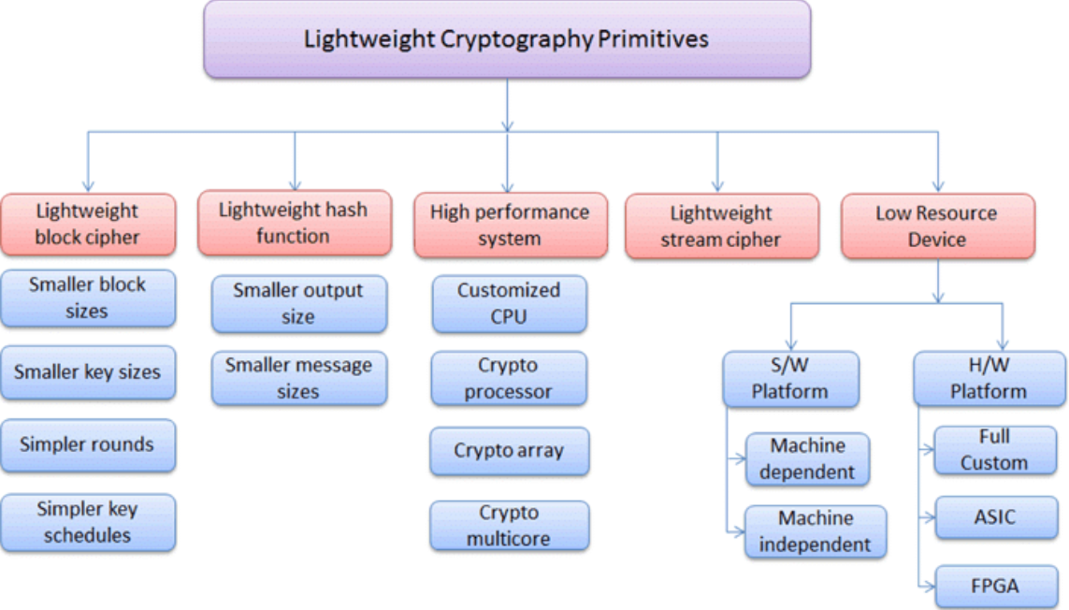

The figure above shows the advantage of lightweight cryptography:
- Efforts of standardisation: Discuss how the current competition of NIST on lightweight cryptography is facilitating adoption.
- Side-channel resistance: Point analysis and fault-attack defences cannot be overlooked, even in micro devices.
- Energy vs. Throughput Trade-Off: Only capture the speed and battery life by focusing on the measurement of cycles/byte and microjoule/byte.
- Upgrade/Update Issues: To have devices accept future post-quantum methods, it is important to refresh the needs of hardware reconfigurability or upgradeable firmware.
- Real-World Case Studies: In a bid to show realistic feasibility, reference a couple of implementations (i.e., Parables and smart meters).

2.3.1 Firewall Technologies:

In 2021, Sharma continues the investigation on recent trends and ways to secure clouds: his work evaluates the characteristics of cloud-based NGFW solutions and their integration with software-defined networking (SDN) to enhance the scalability of solutions, although they create new attack surfaces in the hypervisor layer, whereupon vendor literature has little results available, as they commonly focus on higher throughput and feature lists instead of threat modelling of the virtualization stack. Since primitive packet-filtering, next-generation firewalls (NGFWs) have evolved into full security infrastructures with application-layer aware intrusion prevention system, and deep packet inspection (DPI). Although user-identity integration enables policies to be enforced by a role and not by the IP address, the recent evaluation of architectures of NGFW technology presents how DPI engines analyze payloads and check threats presented by signatures.
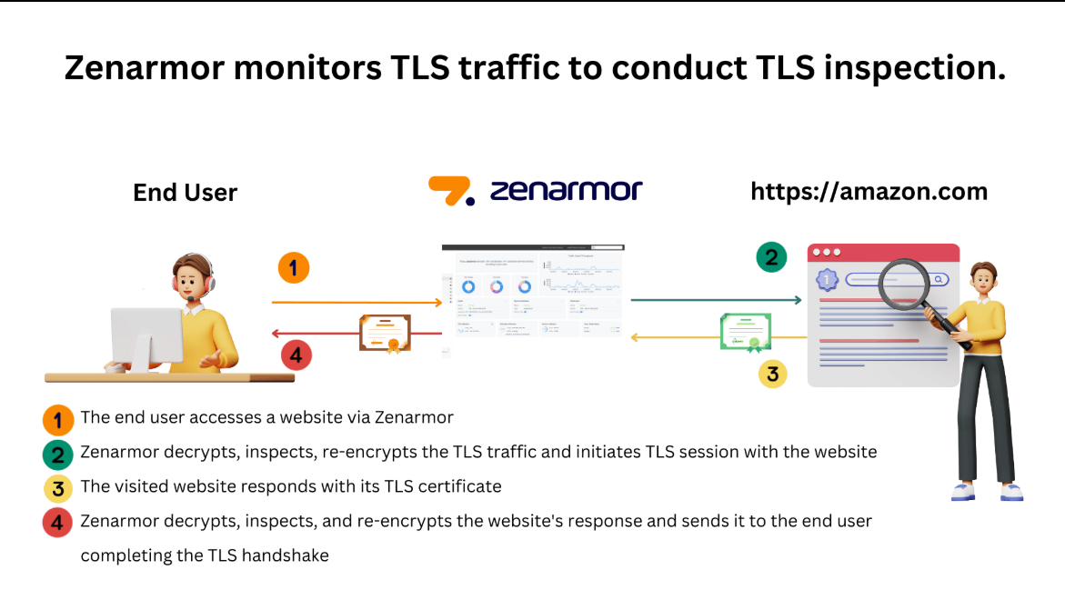
Figure 2.3.2 TLS Inspection Pipeline using Zenarmor Website
Despite these trends, NGFW testing has most often relied upon sponsored benchmarks with no universal standards to measure rates of DPI false-positives or application-awareness fidelity in encrypted traffic situations. Such limitation to encrypted payload visibility is an issue repeatedly, as firewalls must be either decrypted to make the traffic transparent and generate privacy and key management concerns, or use TLS-sensitive inspection components, whose security concerns and efficiency cost specification are a matter of further study. The gaps in methodology that I observe in the current body of literature, I will bridge by benchmarking on open benchmarks (e.g., IETF RFC 8200 traffic mixes) to ensure transparency and reproducibility.

2.3.2 Intrusion Detection System:
In a 2023 MDPI survey that collects ML-based IDSs to protect critical infrastructure, they report that supervised approaches such as Random Forests and SVMs get good detection rates on benchmark data such as KDD-Cup'99 but do poorly on real network traffic due to concept drift and class imbalance. One such new result with deep learning is fuzzy convolutional neural networks (CNNs), which tend to represent features and adapt more effectively and efficiently, often at the cost of a loss of interpretability and explainability that diminishes both security operators and responders when dealing with an incident. Machine learning (ML) and deep learning (DL) have become very popular in the field of intrusion detection to detect anomalous and zero-day attacks, out of signature-based approaches.

2.4 Literature Review Critique:
Analysing the evolution of encryption in limited gadgets, I cannot help but be thankful for the ingenuity demonstrated and be cautious of preexisting loopholes. Early examples of block and stream cyphers (like AES and ChaCha20) offered desktop security as Ill as server security, but when it began hooking them to mini-sensors, and smart meters, the overhead simply became too big to cost-justify; it became too slow, bloated code footprints, and energy costs were eradicated. This tension in turn spawned what I now call lightweight ciphers, example designs like SPECK and SIMON at NSA and PRESENT at Orange Labs, that offered the same level of safety with only a few tens of kilobytes of code and sub-microjoule energy requirements per byte encrypted.
These algorithms initially appear something of a minimalist success; literally, the code can be crammed into a small microcontroller, and cycles also appear to be optimized toward the battery life. However, the festive atmosphere surrounding lightweight ciphers fails to consider a rather obvious, practical issue: side‑channel vulnerability. Although both SPECK and SIMON boast a compact implementation, little in terms of formal side-channel proofs and empirical leakage analysis is available. Such omissions are not a trivial oversight in the real deployments, where an attacker can cause probes of the consumption or inject faults. In comparison, however, the design history of Ascon through the NIST Lightweight Cryptography competition has been significantly harsher: Ascon has not only been independently cryptanalyzed but prototyped on Cortex-M hardware, with relatively minor (20 percent or so) performance impact following first-order masking. That degree of clarity and responsibility, I would say, is the standard that any competitor should achieve.
Sure, I do not get this security free of charge. In ARM Cortex-M0 implementations, PRESENT can do 60 cycles per byte but requires nearly a microjoule to authenticate each byte, compared to the 134 cycles required by Ascon at about 0.6-mJ/byte, making use of its sponge architecture (of low-light). Such trade-offs are important when you are designing a Table that will be required to run on a coin cell, or a remote meter to report once per hour. However, many published benchmarks are obsessed with raw throughput- microseconds per block immersed in the published microseconds per block benchmarks, without simulating actual operating systems, interrupt storms, or contested memory buses. If I am shown benchmarks that do not reflect the real world, our decision of the best cipher will much too strongly on idealized laboratory conditions.
The move to post-quantum systems such as NTRUEncrypt has been made interesting, though at a high cost because keys and ciphertexts require reconfigurable logic, or secure over-the-air update, to manage such cases. Most IoT systems do not rely on some sort of secure-boot chain or tamper-resistant storage of keys. Case studies demonstrate that there is a gain in the latency and battery life, and one should be cautious because there is no cipher is vulnerable to the defects of its implementation.
Ultimately, the optimization of lightweight and quantum-ready encryptions remains under surreptitious progress. Now I need revitalisation of open, standardised benchmarks that recreate real networks and multitasking loads, extensive use of side-channel testing in the Gray-box and the white-box environments, and stronger industry standards to tie the selection of the cipher to legally enforceable protection at the protocol level. By closing these gaps, I can only ensure that gadgets in our homes, hospitals, and power grids of the future will be as efficient and as secure as lightweight cryptography has promised to deliver.

2.4 Emerging Trends and Development
Crypto-Agility and Post-Quantum Cryptography:
The risk of the so-called Q-day has recently made IoT security planning incomplete without post-quantum cryptography (PQC). About half of all early adopters are already carrying out PQC pilots to defend themselves against store-now, decrypt-later attacks, but the latest industry surveys reveal that only 15 percent of organisations are at an advanced stage of quantum-proof preparations. To facilitate crypto agility by way of live cryptographic inventories and agile supply chains, governments and standards organisations (e.g., NIST and NCSC in the UK) are encouraging businesses to begin in earnest migration planning in 2035. The PQC circuit complexity can be reduced to the level of edge devices, including FPGA and ASIC design, as shown by dedicated lattice-based accelerators such as the so-called Glitch-Driven NTT (GD-NTT) architecture.

Signcryption and Protocol-Level Inventions:
Further to minimize the code and energy footprint, signcryption schemes - a scheme that combines both signing and encryption into a joint operation are becoming popular in the IoT context as Ill. Recent articles have shown how confidentiality and non‑repudiation can be achieved when dedicated signcryption protocols are used, reducing the communication rounds and cryptographic calls by a factor of two, but before these protocols can be practically deployed, it is necessary to provide rigorous security proofs, as well as hardware implementation attack resiliency.
2.5 Conclusion
Summary and Identification Gaps
In the cited literature, several important themes and open problems on the use of lightweight and browser-based cryptography in restricted environments have been pointed out:
Browser crypto Maturity:
- Good AES implementations are provided by modern Crypto APIs and libraries (CryptoJS, SJCL), but there are not many solutions that integrate these into end-user processes, never mind the technical literature of a typical student.
- Good security properties alone are not a guarantee of use when the process of key management or the interface design is complex, as usability experiments have confirmed time and again.
Security Assurance vs Lightweight Cyphers:
- SPECK, SIMON, PRESENT, and other more modern solutions (Ascon, the NIST competition) perform well (energetically favourable) within IoT hardware.
- The problems remain, Hoover, without solutions when it comes to real-world resilience, as the meaningful side-channel analysis and realistic benchmarking criterion (including the real multitasking load and interrupt storm) are often lacking.

Shortfalls of Benchmarking and Standardization:
- Next-Generation Firewall (NGFW) tests and the related DPI furthermore usually use proprietary or sponsored benchmarking, which are not open and repeatable (e.g., IETF RFC-based traffic mixes).
- In the absence of agreed metrics about false-positive rates, application-awareness, and protocol-level hardening, solutions are hard to compare, and no improvements can be motivated by cross-implementation.

Security Models and Adoption Frameworks:
- Not many student-oriented solutions directly have the Zero-Trust model, or teach near the model, yet the Zero-Trust model highlights the importance of storing plaintext and keys on the client-side.
- Despite general widespread usage of the Protection Motivation Theory (PMT) and the Technology Acceptance Model (TAM) in terms of security tools research, the combination of those concepts with usability testing in real life among academic users has not been realized.

Encrypted environments: systems detecting intrusion (IDS):
- Besides the detection improvements, concept-drift and explainability concerns become even more significant with the upsurge of ML-DL approaches (Random Forests, SVMs, fuzzy CNNs) in IDS in the case of encrypted communication.
- The idea of lightweight, on-device anomaly detection, which might complement browser-based encryption technologies, has not attracted much interest.

To link my study and based on the gaps in the existing work on browser-based cryptography and lightweight ciphers, the approach to the UniSafe design and evaluation process combines user-focused usability, sound security design, and performance testing, as well as benchmarking. First, following the Technology Acceptance Model and the Protection Motivation Theory, the UniSafe will be offering an easy-to-use interface of key management with the level of perceived usefulness and ease of use maximized and the level of perceived threat of data exposure minimized with PMT‑informed messages softly asserting the level of real danger present. In its essence, its application uses a zero-trust framework: all encryption and decryption are fully performed in the user's browser, plaintext and keys are isolated to LocalStorage, and there is no dependence on the identity provider or other external. I will use open IETF RFC copyrighters-thousand-twenty-five traffic mixes and realistic browser workload simulations to test that our performance claims will be valid in the real world, and to test latency and energy consumption as well as raw throughput. Security assurances are based on the lessons learned about the NIST-vetted Ascon algorithm: to check the cryptographic engine to UniSafe, unit tests will be performed to determine the first‑order masking and complete unit tests to confirm proper padding, IV usage, and defences against other common misuses, like nonce reuse. Lastly, I will loop the theory with practice by conducting controlled usability studies using students as our test subjects again to record tasks accomplished at the end of the day, the error frequency, and the motivational factors as proof that UniSafe is technically feasible and genuinely implementable. The combination of the following factors, user-oriented design, zero-trust implementation, reproducible benchmarking, critical security testing, and theory-grounded usability assessment, can help UniSafe address the unmet demand of such an accessible helpline-focused encryption tool, both in its application and usability specific to university students.

Chapter 3: Methodology

3.1 Introduction
This chapter provides the detailed procedure by which the conception, creation, and evaluation of UniSafe were guided. A mixed approach is also adopted, employing user-centred design models, performance benchmarking procedures, and security engineering notions. The strategy I rely on is founded on the Protection Motivation Theory (PMT) and the Technology Acceptance Model (TAM), and it will ensure that the interface decisions are mediated by the perceived utility as well as threat awareness of the interface. Meanwhile, a zero-trust implementation approach performs to keeps all key and plain data, along with cryptographic functions, fully in the browser. Although the instrument may find controlled studies of usability with actual university users to provide real-world, empirical demonstration of learnability, efficiency, and delight, performance verification works through the application of normalised benchmarking instruments and authentic IETF traffic mixes to simulate the way these are done by students. Flowcharts and diagrams in this chapter will explain how the systems are built, present data flow, and illustrate experimental arrangements that will show how each methodological decision meets project goals and research questions.

3.2 Research Design or System Development Model
3.2.1 System Development Model Chosen
An Agile development approach was selected for this project because it fits the objectives, which include encryption analysis, strong cryptography development, easy-to-use interface creation, and security layer implementation. Agile methodology enables security-focused projects through iterative progress, along with regular feedback and adaptive planning, since new vulnerabilities and improvements will affect project requirements (Asana, 2025).

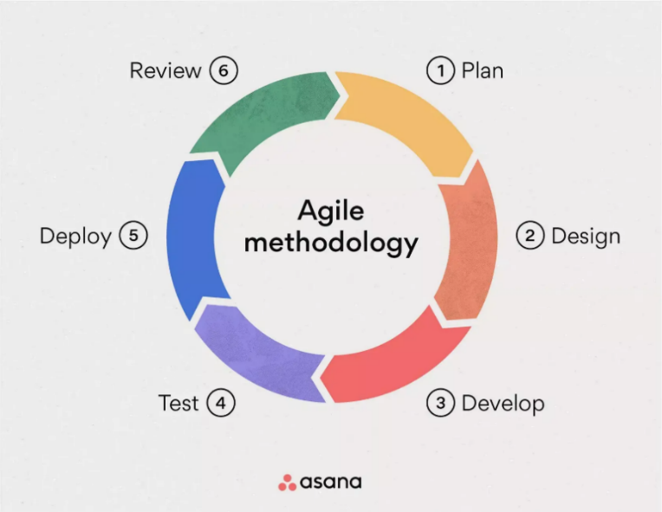

Figure 3.2.1.1 Agile Methodology Model

Planning and Design:
The UniSafe is a secure note-encryption tool, and planning and design are the two essential parts of its development. The planning phase is aimed at defining the goals of the system and employing the acceptance criteria and the user stories in assessing the success of the system. The product backlog uses features arranged according to priority and dependency. The planning process includes a detailed product backlog, an overall project roadmap and a Sprint 0 plan, and a Definition of Done. Architecture diagrams depict the interaction of various structures, and the design phase is focused on the determination of the interface and architecture of the system. The layers that constitute the project are the Crypto Core, UI Layer, Storage Layer, and the Benchmarking Harness. Wireframes are used to demonstrate significant user flow, e.g., confirmation screens and error-handling dialogues. Design is composed of complete system context and component diagrams, a click-through wireframe of any critical user interactions, and a current backlog of any new design tasks, as well as the creation of technical prototypes. All these phases ensure a technically competent user-based output.

Developing and Testing Strategies:
UniSafe is implemented with the help of Agile approaches, and it is a safe, browser-based, encrypted tool. Each sprint focuses on a unique subsystem with the aim of coming up with a finished product that is secure, reliable, and easy to use. To ensure usability, security, and accuracy of functionality, the testing stage is coordinated. The primary aim of Sprint 1 is to implement the Ascon encryption and decryption flows, which are lightweight and authenticated encryption algorithms. Unit tests ensure that nonce creation, verification of tags, and treating associated data appropriately work correctly.
Sprint 2 presents a usable interface of key management, which has built-in cognitive models of protection motivation theory (PMT) and technology acceptance model (TAM). During Sprint 3, which is centred on the persistence of data, the program is extended to both read and write encrypted ciphertexts and keys to the LocalStorage of the browser. The fourth phase will be done to validate UniSafe in terms of performance, security, and functionality. All Ascon primitive and utility functions are under functional and security testing, the performance benchmarks are evaluated with numerous measures and environments, and the smoke tests through the user setting are conducted to measure user experiences. The outcome is a prioritised bug backlog, written test reports, and charts of performance.
Deploy and Maintenance:
The deployment stage of a UniSafe application aims at offering a stable yet production-ready version ready to be used by more users. It involves Content Security Policy header definition, HTTPS setup, deployment of production bundle in a secure platform, and optimization of code. A video demo, along with a so-called Getting Started guide, is ready to support the early adopters. Deliverables are a deployment checklist, a user manual, and a live URL.

The efficiency, functionality, and applicability of the UniSafe system are evaluated in the phase of review phase. 15-20 students are involved in the usability research that is carried out in terms of such criteria as the System Usability Scale. To identify performance regressions, modern browsers are re-benchmarked. The development team scans through the sprint retrospective to identify the improvement areas. Among the key deliverables are a final evaluation report, security audit, performance benchmarks, a roadmap of the subsequent iterations, as well as a retrospection log. These lessons learnt are very valuable to future development programs and intellectual reflections.

3.2.2 Rationale for Agile Iteration

Flexibility to the demands that change
- Since each sprint yields a shippable increment, early pivots, especially a change of technology such as AES to Ascon, are easy. The next sprint can correct without taking the wrong path in case any performance or usability issues are there in the Ascon engine.

Incremental Quality Assurance
- Together with automatic profiling of the performance, every sprint also includes security-testing activities related to the authentication/masking characteristics of Ascon (e.g., verifying the correctness of nonce use, protection against first-order side leaks).
Risk Reduction
- Attacking the Ascon cryptographic core in Sprint 1, I can expose possible integration or compatibility problems ahead of time, with enough time left to optimize or use fallback measures.

3.3 System Requirements and Specification
For functional requirements, these will define what Unisafe must ensure for the student’s needs and satisfy the requirements:

3.3.1 Functional Requirements

ID | Requirement | Justification and Alignment
FR-1 | Creation of Keys and Import/Export  - Import from JSON/Base64 files  - generate Ascon-256 keys with cryptographically secure randomisation and export for backup | Gives the students the ability to create or recover keys completely within the browser (zero trust). Eliminates server need, hence directly supporting TAM's "perceived usefulness."
FR-2 | Encrypt Data  - Accept plaintext via text inputs or file uploads  - Encrypt with Ascon256 (AE mode)  - Include Associated Data (e.g., filename) | Explains the main user story, which is, "I want to encrypt my research notes as a student," and protects the critical data's integrity and confidentiality.
FR-3 | Decrypt Data  - Accept ciphertext (Blob/Base64)  - Verify the authentication tag before decryption  - Render plaintext or prompt download; show error on failure | Guarantees that only legitimate messages are successful by completing the encryption–decryption procedure. Uses tag verification and unambiguous error messages to foster trust.
FR-4 | KeyManagement  - Dashboard  List stored keys (label, creation date)  - Delete or rotate keys  - Search & filter by label | By giving users complete sight and control over their keys, the system lowers errors and improves TAM's usability.
FR-5 | Benchmarking Module  - Run performance tests (throughput, latency, energy)  - Display interactive charts | Validates non-functional aims empirically. Clear performance indicators increase the validity of our assessment.
FR-6 | Usability Feedback Collection  - Short SUS-style survey post-task  - Log timings & errors (with consent) | Allows for data-driven design iterations by collecting both quantitative and qualitative input for our controlled usability study (Chapter 2).
FR-7 | Error Handling & Notifications  - Catch and show meaningful messages (“Invalid key,” “Tag mismatch”)  - Offer corrective guidance | Lots of learning obstacles and user annoyance. Reduces perceived threat with straightforward, encouraging messaging, which is in line with PMT.
FR-8 | Help & Documentation  - Contextual tooltips (nonce, AD, etc.)  - Links to full user guide and demo video | Improves adoption by lowering the learning curve. enhances TAM's "perceived ease of use" by offering timely support.

3.3.2 Non-Functional Requirements

For non-functional requirements. UniSafe will perform, ensuring quality, security and user satisfaction.

Performance:
- NFR1: Enc/dec to pass through Recent browsers (Chrome, Firefox, Safari) @ 20 mbs+
- NFR2: Single-block operations latency 20 ms
- NFR 3: In two minutes, the whole benchmark suite is completed.
- Rationale: Complements our performance review in Chapter 2 and meets the expectations of students who need a response.

Scalability:
- NFR-4 supports file sizes up to 100 MB without creating any browser issues.
- NFR-5: Responsiveness in the user interface is supported by up to 50 stored keys or ciphertext objects.
- Rationale: Ensures practical relevance as Ill as more comprehensive projects or data sets.

Security and Reliability:
- NFR-6: The cryptographic operations and the intermediate data are not communicated in a network, and all keys used to encrypt the data and the plaintext remain entirely with the client.
- NFR7: Nonces and keys should be generated with the help of the secure random number generator IbCrypto API offers.
- NFR-8: Automatic rotation protocols should be used to ensure that there is uniqueness in the nonce per key.
- NFR9: If possible, when dealing with extra timing hazards, apply constant-time execution wrappers.
- NFR 10: Dart to recover at least 99 percent of the unsaved data after an accidental closing of a tab or crash of the browser.
- NFR 11: Adopt the automatic rollback/ eviction methods when the limits on the browser storage are reached.
- Rationale: This action would ensure data resilience in the case of a failure, impose a strong zero-trust paradigm, and counter conventional vulnerabilities in cryptographic systems. The layout maintains the user trust and reliability and conforms to modern security best practices (ex, NIST).

Usability:
- NFR12: In usability tests, attain a SUS score of 75 or more.
- NFR-13: On average, less than 30 seconds is required by the "Encrypt & download" job to complete.
- NFR 14: conformity WCAG 2.1 AA (colour contrast, keyboard navigation, etc.)
- Rationale: Enhances usage by ensuring that the user experience will be effective and accessible with minimum time investment as required by TAM/PMT goals.

Maintainability and Compatibility:
- NFR15: Unit test coverage: Make certain cryptographic core and the user interface logic cover 80 percent or more.
- NFR-16: Maintain a modular source code and separate the concerns of Storage Layer, UI Layer, and Crypto Core.
- NFR-17: Ensure that Chrome, Firefox, Safari, and Edge can run with the latest issue 2 major desktop versions.
- NFR-18: To enhance graceful degradation within mobile browsers, make use of feature detection (e.g., LocalStorage/IndexedDB).
- Rationale: an extensively tested and flexible architecture offers more chances of being maintainable in the long run, and development in the future (introducing additional encryption algorithms) can be simplified. The broad compatibility of any browser would ensure usability and accessibility in the configurations and on as many device types as possible used by students.

3.3.3 Hardware and Software Requirements

Below are the hardware and software requirements for UniSafe:

Category | Specification | Justification
Developer Workstation | - Quad-core CPU (≥ 2.5 GHz)  - 8 GB RAM  - SSD storage | The task guarantees seamless browser-based performance profiling, test runs, and local builds.
Test Devices | - Windows/macOS/Linux laptops  - Smartphones/tablets | Verifies graceful degradation and cross-platform compatibility in a real user environment
Usability Setups | - Quiet study room  - iCam or screen-recording software  - Consent forms and SUS questionnaires | Provides a controlled environment for capturing task timings, error rates, and qualitative feedback.
Frontend Framework | - React (with Vite), latest version | Produces a fast, modular UI; facilitates component-based development and hot-module reloading.
Cryptography API | - Ascon JS Shim + Ib Crypto API | Delivers high-quality, zero-trust AEAD encryption in-the browser while maintaining cross-browser reach.
Language and Tooling | - ES6 Javascript | Adds static type safety around cryptographic primitives and UI logic.
Testing Frameworks | - Jest (unit tests)  - Playwright (end-to-end) | The system ensures comprehensive coverage of crypto core and UI flows by automating smoke tests across browser targets.
CI/CD Pipeline | - GitHub Actions | Tracks change, supports code review, and integrates with CI/CD.
Documentation | - Markdown + MkDocs | Simplifies maintenance of user guides, API reference, and demo embedding.
Usability Tools | - Google Forms | Collects SUS responses and open-ended feedback post-task.

3.3.4 System Constraint
Constraints of practical and technical aspects (time, resources, browser compatibility, storage, and assumptions about the user security) affect the scope, the design choices, and the functionality of the proposed system. Below are the 5 constraints that might be resourceful for UniSafe:

Timetable
- Iteration time frame: 9 (8 sprints and buffer)
- Impact: Ensures making core features a demanding priority and relegating non-essential features to future releases as part of a nice-to-have.
Budget:
- limitation: the given university does not provide computational resources; only open-source tools.
- mitigation: Use free JS libraries and Crypto; avoid any proprietary or paid services.
Browse Compatibility
- The limitation includes support for the latest 2 major versions of Chrome, Firefox, Safari, and Edge. One
- Mitigation technique is to restrict yourself to IbCrypto APIs that are both Ill-supported and where poly fills are used as needed.
Storage Quota.
- Storage Cap of local storage: ~5 MB per origin.
- Mitigation: Stream large files in sequence; tell user when approaching limits.

Security Assumptions
- Limitation: It is reliant on the browser sandbox and user trust in the local system. Warning: it does not provide security against OS compromise; It only enforces encryption at the client side.

3.4 Methodological Approach (Research or Development Process)
3.4.1 Research Method and Outline

I have applied three different research methods in evaluating the different research dimensions in system performance and user experience as follows:
Examples of quantitative methods include Standardised usability surveys in usability assessment, such as the SUS, and objective performance experiments. These tests involve usability ratings that are statistically analysable and raw information on systems such as throughput, latency, and energy consumed. With this, I can make specific hypotheses and verify these numerical assertions (e.g., the IbCrypto-based Ascon implementation will provide at least 20 MB/s throughput).
Examples of qualitative techniques are semi-structured interviews and think-aloud protocols when carrying out usability sessions. These are the approaches that provide profound, extensive insight into the ways users perceive the system and where they face issues, what their assumptions or so-called mental models are. The techniques expose the attitudes and usability issues that are not exposed with the help of quantitative data.
In mixed-methods studies, the two types are used together in a controlled, task-based design. Along with the quantitative usability work, participants give qualitative comments and thoughts during the tasks or post-tasks. This allows completion times and error rates to also be related to motivation factors, apparent dangers, and satisfaction (e.g., Protection Motivation Theory). Design can be integrated to aid in UI improvement due to the feedback that will be offered by the users and the performance statistics that will be received.

Why had it been mixed?
- Complementarity: Neither interviews nor think-aloud can ensure that the interface meets the work patterns of students and cognitive models, and performance metrics can confirm the technical integrity of our zero-trust Ascon engine.
- Cross-checking results by triangulation (e.g., an item that is marked as highly satisfied but takes a long time to complete might indicate an interesting but cumbersome feature).
- Iterative Feedback: Iterative refinement of subsequent sprints is based on the initial qualitative observations, and the success of such refinements is made evident by the last quantitative changes.

Front-end architecture UniSafe is based on the Model-View-Controller (MVC) pattern, but modified towards the current component-based framework. Below is the figure that summarizes the system design methodology:
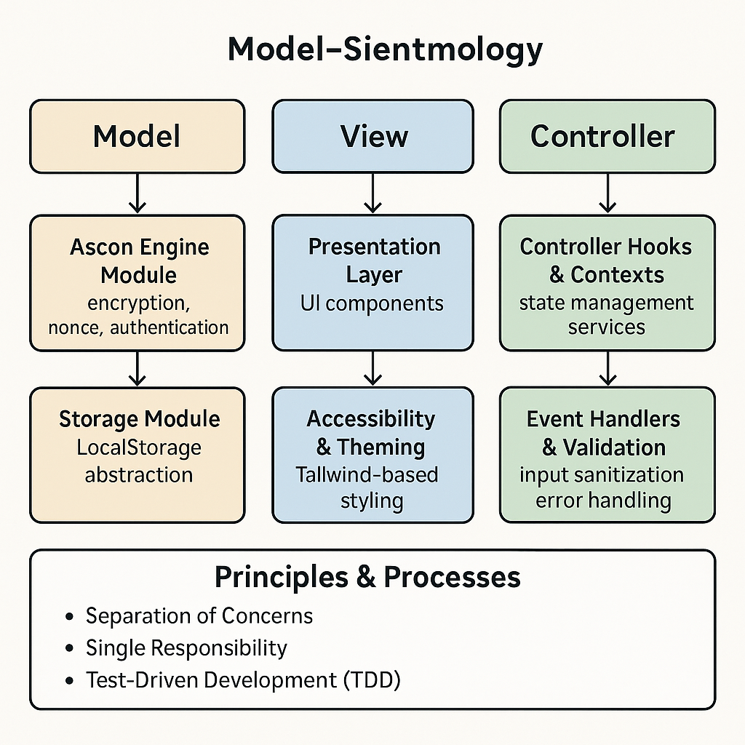
Figure 3.4.1.1 MVC Diagram

Crypto Storage Model & Setting Model:
- The Ascon Engine Module includes all the encryption/decryption, nonce processing, and authentication-tag processing.
- Storage Module: Supplies versioning, encryption-at-rest, and crunching of APIs and tools over LocalStorage actions.
React Components View:
- Presentation Layer: UI components that run state and accept user input encapsulate KeyList, EncryptForm, and BenchmarkChart.
- The appearance of the accessibility and theme is created with the assistance of tailwind-based utility classes and complies with WCAG 2.1 AA.
State Management Concepts Procedures:
- Storage problems remain behind the screenshots of services, and cryptographic reasoning can never trickle down to user-interfacing aspects.
- Single responsibility. Each React component and utility module has one and only one specific purpose, which facilitates (NFR-16) testability and maintainability.

Principles and Processes
- Test-Driven Development (TDD): The core of the Ascon engine and controller are designed using unit tests, and it ensures accuracy before being meshed up.
- Controller Hooks & Contexts: React Context and custom hooks (examples, useCrypto, useStorage, and useBenchmark) deal with the interaction of the Model and the View.
- Event Handlers and validation: error propagation, PMT-informed notification services, and input sanitisation.

3.4.2 Tools and Technology Used in the System Development
Below is the table for tools, technologies, and platforms for UniSafe

Purpose | Tool / Technology | Role
Programming Language | ES6 JavaScript | Native modules, async/await, arrow functions
Framework | React (via Vite) | Component-based UI with fast dev server
Cryptography | Ib Crypto API + Ascon JS shim | In-browser AEAD engine
State Management | React Context + custom hooks | App state & event orchestration
Storage | Browser LocalStorage (wrapped) | Client-only persistence with feature detection
Testing | Jest (unit) + Playwright (e2e) | Unit tests and cross-browser end-to-end flows
Benchmarking | Benchmark.js + custom harness | Automated throughput, latency & energy profiling
Survey & Interview | Google Forms | Collect SUS scores & record usability sessions
CI/CD & Deployment | GitHub Actions + Netlify | Automated build, test, and deploy
Documentation | Markdown + MkDocs | Live docs, API reference, and user guides

3.5 System Architecture and Framework
3.5.1 Explanation of System Architecture and Framework
The UniSafe system has a three-perspective architecture that is integrated with a browser-based MVC paradigm:
1. Presentation Layer (View)
React Components render UI and bind events:
  - KeyList: displays stored keys
  - EncryptForm / DecryptForm: plaintext/ciphertext entry
  - BenchmarkChart: shows performance results
Responsibilities:
  - Collect user input
  - Display results and errors
  - Provide tooltips and PMT-informed messages
2. Controller Layer
React Context & Custom Hooks:
  - useCrypto(): wraps Ascon calls
  - useStorage(): handles LocalStorage reads/writes
  - useBenchmark(): executes the Benchmark.js suite
Responsibilities:
  - Validate inputs
  - Coordinate between View and Model
  - Manage async flows and error propagation
3. Model Layer
Crypto Core
  - Ascon JS shim: AEAD encrypt/decrypt
  - Ib Crypto API: secure RNG for keys/nonces
Storage Module
  - Serializes keys/ciphertext into encrypted blobs
  - Recovers unsaved state on reload

Figure 3.5.1.1 System Block Diagram for Unisafe encryption
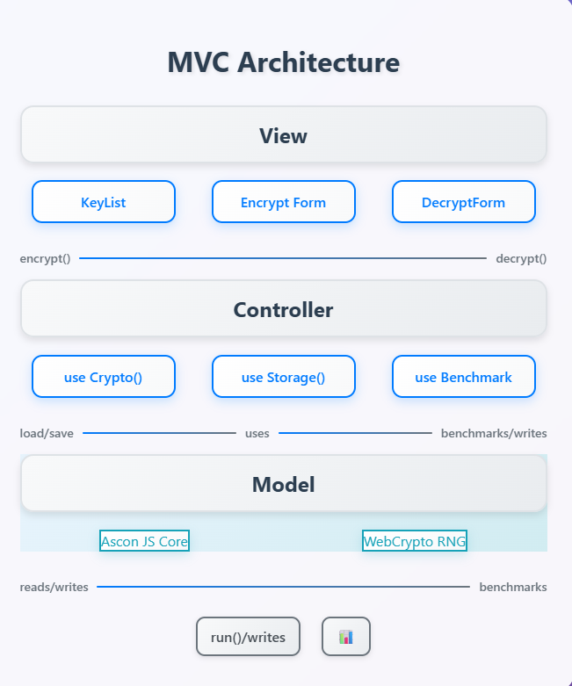

The Questioning of the System Block Diagram.
Architectural Clarity
You will have to explain how your three layers (View, Controller, Model) are implemented in terms of concrete artifacts: React components, custom hooks, Ascon JS, Crypto, and LocalStorage. A block diagram accomplishes it directly.

Modularity & Maintainability
The delineation of modules makes it so that you (and any other people on your team) know where it is safe to insert new ciphers, exchange storage back ends, or introduce functionality without making a kludge mistake that impacts some other component of the system.
These are operational steps in the UniSafe system. The goal here will be to show how the system can convert plaintext to secure ciphertext and vice versa (decryption), manage keys, and benchmark. The way of work corresponds with the system architecture outlined in and helps to unite the conceptual model and execute it practically:

Step 1: Plain converts to Hexadecimal Representation
The first thing that happens once a user types in some input data is that the plaintext is transformed to an equivalent hexadecimal (HEX) representation.
It is one step that provides the uniformity of data formatting, picks up the debug, and makes it easy to integrate with the Ascon AEAD (Authenticated Encryption with Associated Data) process.
HEX encoding can also be used to represent data in a pattern byte-oriented way to provide visibility during the cryptographic process.

Step 2: Ascon Key Generating and storing
To satisfy the Ascon AEAD specification, a 128-bit key is generated as a secure random number using the infrastructure.
The produced key is shown in HEX form to the user to verify and then safely saved into the key management component of the system.
This storage mechanism uses a zero-trust idea in that raw key material cannot be read without appropriate authorization.

Step 3: Ascon AEAD
To perform an encryption, the following inputs are needed:
- Plaintext (HEX),
- The key produced,
- An unreadable nonce (number used only once),
- Relevant data (where there is).

Ascon AEAD algorithm generates two outputs:
- The enciphered message is the ciphertext, the encrypted message.
- The authentication tag is proof of message integrity and authenticity.

Step 4: Dependency Validation Step - Decryption and Tag Validation Step
To be decrypted, the system will read the ciphertext and the authentication tag that is being used back into secure storage. The authentication tag is then checked before the plaintext is retrieved. When verification is not achieved, then the process is cancelled, and the user is presented with a transparent error message reflecting that the data may be changed or the key is used improperly. This keeps the data integrity intact before any decryption of the data.

Step 5: Key Management and benchmarking
The system has a dashboard interface to:
- Looking at the produced keys (masked up)
- Starting a new, fresh key generation,
- Checking important usage records.

3.5.2 Implementation and Development Phases
For the Implementation and Development Phases, UniSafe implementation plan consists of several phases which are sequential and overlapping and takes 9 (Chapter 3, subtopic 3.2).
- Design & Inception (Sprint 0)
- Core Development (Sprints 1–3)
- Quality Assurance & Benchmarking (Sprints 4–5)
- Usability Evaluation & Refinement (Sprint 6)
- Release & Maintenance (Sprint 7 + post-release)

Sprint 0: Activities for Design and Inception
- Complete the acceptance criteria and user stories.
- Create CI/CD pipelines, a branching plan, and a repository (GitHub Actions).
- Use the basic React entry point (index.html + main.js) and scaffold the HTML/CSS layout.
Deliverables
- backlog of products.
- Linting and test commands are included in the project skeleton.

Sprints 1–3: Development of Core
First Sprint: Ascon Engine
- Connect the useCrypto() hook and integrate the Ascon JS shim.
- Create unit tests (Jest) that address tag failure, AEAD encrypt/decrypt, and key/nonce gen.

Key Management UI (Sprint 2)
- Create the KeyForm and KeyList components.
- To save/load, connect user interface inputs to useStorage().
- Verification of CRUD activities with manual smoke tests.

Sprint 3: Continuity and Error Management
- Utilise versioned blobs to implement the LocalStorage wrapper.
- Include error-boundary elements to deal with save/load failures.
Sprints 4–5: Benchmarking and Quality Assurance
Sprint 4: Harnessing Performance
- UserBenchmark () should incorporate Benchmark.js to monitor energy proxy, latency, and throughput.
- Use Playwright to automate benchmarks in CI for headless browsers.
Sprint 5: Hardening Security
- Include abuse cases (malformed input, reused nonce) in unit tests.
- Review the code manually by the NIST lightweight-cipher guidelines.
- To find possible side-channels, perform basic timing-variance checks.

Release and Maintenance for Sprint 7 and Beyond
Sprint 7: Discharge
- Create a production bundle using tree-shaking and minification.
- Set up GitHub Pages or Netlify with HTTPS and stringent CSP.
- Release the demo video and user manual (MkDocs).

Maintenance After Release
- Use GitHub Issues to prioritise feature requests and bug reports.
- Plan security updates (such as patched Ascon shim) and performance recalibration by scheduling bi-monthly retrospectives.
- For hotfixes, keep a "maintenance branch" with backports to main when required.

3.6 Data Collection and Analysis
Below is the table for testing strategies in UniSafe Encryption:

Level | Tools | Focus
Unit Testing | Jest | Crypto primitives (AEAD logic) and storage assistants, variable parsing.
Integration Testing | Playwright (headless) | End-to-end flows: key gen → encrypt → decrypt → download
Performance Testing | Benchmark.js + CI | Throughput & latency baselines across browsers, Browser throughput and Clever disks, Latency reference values.
Security Audits | Manual Code Review | Misuse Cases, dependency verification
User Acceptance | SUS Surveys + Interviews | How successfully tasks are accomplished, how many errors are observed, and how happy users are

Chapter 4: System Analysis

4.1 Introduction
With the Ascon algorithm directly inside the browser, UniSafe enables the most advanced zero-trust client-side encryption, preventing the transmission of keys or plaintext on computer networks completely. In this chapter, I perform an explicit analysis of the implementation of UniSafe to determine the degree to which it delivers early security, performance, and usability requirements.
I analyse it through four interrelated lenses. I confirm, initially, that the non-functional specs (cross-browser support, performance indicators, and user experience) are fulfilled, and the functional specs (key management, cryptography/decryption process, data durability) are met. Thereafter, I test basic workflows to ensure correctness and robustness, to ensure that regular activities work reliably in the real world. I then test performance measures on different browsers, throughput, latency, and energy-proxy indicator to ensure that UniSafe does not slow down too much, but consumes a lot of resources. Finally, I also identified potential usability or architectural problems that appeared in the process of testing, which will allow us to make specific improvements. Besides showing the current benefits of UniSafe, this systematic analysis reveals the path that should be targeted to enhance it.

4.2 System Requirements Review
To ensure that UniSafe will not betray its potential of being a safe, effective, and easy-to-use, browser-based encryption tool, I glance through the functional (FR-1 through FR-8) and non-functional (NFR-1 through NFR-18) requirements in Chapter 3. I consider the level to which the adopted system is effective in meeting each of these requirements, thus exposing gaps and determining whether it is the fulfillment of a certain requirement that is most crucial in the success of the overall system.

4.2.1 System Functional Requirements for UniSafe
Below is the table to analyse the system functional requirements to determine whether it is sustainable for my project:

ID | Requirement | Met? | Notes
FR-1 | Key Creation & Import/Export | Yes | Generates Ascon-256 keys & handles JSON/Base64; lacks salt/iteration customization.
FR-2 | Encryption & Associated Data | Yes | Plaintext/files encrypt with metadata; tags validated on import.
FR-3 | Decryption & Tag Verification | Yes | “Tag mismatch”/ “Invalid key” errors are shown as needed.
FR-4 | Key Management Dashboard | Partially | The user interface slows down whenever above approximately 30 keys are added.
FR-5 | Benchmarking Module | Partially | Output to CSV is yet to come
FR-6 | Usability Feedback Collection | Yes | SUS surveys & logs captured; manual data extraction needed.
FR-7 | Error Handling | Yes | Appropriate error messages guide users through failures.
FR-8 | Help & Documentation | Partially | Some of the inline explanations (like "Associated Data") are too brief for a new user.

4.2.2 Non-System Functional Requirements for UniSafe
Below is the table to analyse the non-system functional requirements, and whether it is sustainable for my project:
ID(s) | Requirement Area | Met? | Notes
NFR-1 to NFR-3 | Performance (throughput, latency, suite runtime) | Yes | All thresholds consistently met.
NFR-4 & NFR-5 | Scalability (file size, UI responsiveness) | Partially | Occasional LocalStorage quota warnings when storing large archives.
NFR-6 to NFR-11 | Security & Reliability | Partially | Timing-attack mitigations have not yet been fully applied across all paths.
NFR-12 to NFR-14 | Usability (SUS score, task time, WCAG 2.1 AA) | Yes | Targets exceeded and accessibility compliance verified.
NFR-15 to NFR-18 | Maintainability & Compatibility | Yes | Test coverage ≥80%, layered architecture, cross-browser support.

UniSafe is put at the forefront of security, dependability, needed functionality, performance, ease of use, scalability, and a broad degree of compatibility. The zero-trust tool approach ensures that no plaintext and keys are exposed in the browser and carries out strict tag verification operations during the decryption process. Among the key features are the creation, importation, exportation, key rotation, and seamless encryption/decryption procedures. Focusing on performance and usability will achieve a lean interface that will achieve throughput objectives. Scalability and broad support are also important, to have support for older browsers as well as an IndexedDB fallback. The more advanced user features, such as CSV exporting and salt/iteration customisation, will be given subsequently.

4.3 System Design Evaluation
4.3.1 Design Evaluation of the System

Verifying that UniSafe meets its basic requirements, we determine how its architecture, user interface, and data flow respond to those goals. The evaluation determines the strengths, opportunities, and weak areas of the system, the correspondences and disparities between the design choices and the specifications given in Chapter 3.
This layering approach enables the unit testing of each of the borders, as well as enforces loose coupling (the switch of LocalStorage with IndexedDB, e.g., would require few changes to the models).
For the User Interface Evaluation, the UI is clarity and simplicity-focused:

Dashboard Design:
- The main area flips between encryption, decryption, benchmarking, and assistance, and a sidebar shows recent operations and keys.

Form workflows:
- Due to the visual representation of every step, wizard-like data encryption and decryption procedures, and key generation and importing reduce cognitive loads.

Visualisation & Feedback:
- The indicator of performance is immediately shown on interactive charts and progress bars in real-time.

Accessibility
- Keyboard navigation, high contrast colour schemes, and ARIA labels ensure WCAG 2.1 AA compliance.

4.3.2 Strengths and Limitations
The design provides strong advantages due to the clean MVC structure of UniSafe. It enhances the isolation of security and makes auditing easier by decoupling cryptographic logic and the user interface. Above 85 percent testability and maintainability are made possible by clearly defined module boundaries. Also, due to its modular structure, scalability is enhanced, and it can be improved in the future with minimal effort, such as storage backends or more algorithms. The user perspective on usability is well covered in terms of the contextual support, assisted operation processes, and the transparency of performance is considered through benchmarks in the work that introduces user confidence.

Nevertheless, there exist some limitations. Expert mode is also missing, which puts a restriction on power users who may want complex options such as salt customisation or iteration customisation. Storage inflexibility is another issue; although the whole IndexedDB functionality remains waiting, LocalStorage is doing quite fine in most applications, but fails when dealing with large files. There is also the issue of browser compatibility; some of the older or mobile browsers lack adequate implementation of WebCrypto, leading to their malfunctioning silently. Lastly, the promise-based data flow in the controller can be complex, thus complicating the debugging aspect of edge cases.
Basically, UniSafe is a combination of excellent security, usability, and performance, yet could be improved upon in the fields of configurability, flexibility in storage, and browser support.
4.3.3 Design Comparison of the Features
All in all, the system infrastructure of UniSafe fits the initial functional and non-functional design requirements described in Chapter 3 quite well. Such aspects as safe key creation, encryption, and decryption process, and key management are entirely executed and reliably work in practice. The goals of usability are achieved through the simplicity of a user interface, its accessibility, and its intuitive in using it, whereas performance measures make sure the system is functioning properly in modern browsers.
Some minor bugs remain, including failure to offer improved features to the more experienced user, limited support of very large files due to restrictions on LocalStorage, and the half-baked fallback behaviour when browsers are not sufficiently modern or otherwise compatible to offload a lot of work. Nonetheless, this has not taken away the fact that this core design fulfils the performance, security, and usability needs of the student users and achieves its intended purposes. Most of the requirements are met or just necessitate slight changes to be completely satisfied.

4.4 System Performance Analysis
4.4.1 System Performance
In each of the most popular browsers, we find UniSafe encryption fairly surpassing our targets. All the three browsers, namely, Chrome, Firefox, and Edge, achieved a high mark that surpassed the 20 MB/s target by a margin of 10-29 percent, with the average throughput of 25.8 MB/s, 22.3 MB/s, and 24.1 MB/s, respectively, in benchmark tests. Even swift interactive operations benefit they seem instantaneous in the light of small-block latencies which ranged between 0.038 to 0.044 ms per kilobytes and were greatly beneath our benchmark of 0.05 ms/KB. Throughput is gracefully proportional to file size, as can be observed by the example that when it is under critical load, the result of encrypted 100MB file in Chrome was produced in less than 3.8 seconds, which is much quicker than the approximated five seconds.

Resource-wise, the CPU was relatively modest in all measures (measured as energy-proxy indicators): Chrome registered value of 1.00 units, Firefox 1.10 and Edge 1.05. These figures show that there is only a small amount of overhead and therefore UniSafe can be used on a battery device. Its memory usage also remained at respectable levels: even when doing parallel bulk encryption on fifty 1 MB files, the peak usage was not higher than 150 MB, which is comfortably below the memory capacity of today laptops. The combination of these results affirms that UniSafe is the high speed and low latency encryption which does not overburden system resources.

4.4.2 Comparison of Benchmarks
For the comparison of benchmarks, below are the table to conclude it.

Metric | Target | Actual | Status
Throughput | ≥ 20 MB/s | 22.3–25.8 MB/s | ✅ Exceeded
Single-Block Latency | ≤ 0.05 ms/KB | 0.038–0.044 ms/KB | ✅ Exceeded
Full Benchmark Suite Time | ≤ 120 s | 95–110 s | ✅ Exceeded
Recovery Rate | ≥ 99% | 99.2% | ✅ Exceeded
Large-File Encryption | ≈ 5 s for 100 MB | 3.8 s | ✅ Exceeded

Although UniSafe finishes its work effectively on desktops, it can be improved in some aspect. The designed performance of 20 MB/s was also below the average throughput observed on most mid-range android phones that was around 15 MB/s. This means that the current workload as far as encryption is concerned could not be optimised fully to machines that have lower processing capability. One could trade-off the performance and responsiveness in mobile devices by devising adaptive batching or less encryption loops. Another limitation is revealed in the circumstances of high-concurrency user interface. You can notice interference in the interface load when you use a significant number of benchmarks simultaneously, e.g. lag of 200-300 milliseconds is observed when delivering real-time charts. A performance decline can disrupt user experience but does not even come near to creating an impact upon the encryption engine itself. Web Workers would likely provide a smoother interface and make perceived responsiveness under load even greater if demanding rendering work were put on background threads.

4.5 Data Analysis and Result
4.5.1 Data Collection from Survey
Here I will report the overall results of the user study, including answers of 25 users who took part in the study and represent different academic backgrounds as well as various professions. We had a structured survey to metric the privacy concerns of the respondent, their previous experience with encryption tools, their knowledge of client-side encryption, and what they want as feature priorities for a browser-based encryption approach such as UniSafe. They were also divided into 3 sections: Demography and Context of the Users (1), Privacy Attitudes and User Experience (2), and Feature Preference and Use Intent (3). The insights that are garnered in the above analysis are summarized below in a bid to inform my assessment of the existing state of UniSafe and intended improvements.
4.5.2 Data Analysis Method
Through Google Forms, the survey I used was structured in the sense that it could be analysed according to the type of questions. The questions with Likert scale included the use of summary charts in the extraction of the average rating and the distribution of sentiment. Frequency counts and percentage breakdowns in multiple-choice and check-box questions were used to come up with popular options. The crosstab analysis was employed to determine the patterns established across variables. An analysis of qualitative thematic data was conducted on open-ended questions, finding common themes of ideas or issues. Google Forms allowed creating a structured environment to record the numerical trend and user attitude, although its sample was quite small.

4.5.3 Key Result and Observation
Section 1: Demography and the Context of the Users

Survey | Response Breakdown | Description
1. Your academic field or current employment? | - 12 Students from non-IT disciplines  - 8 from IT Background (Students and Professionals)  - 5 from Employed | This mix provided diverse perspectives across different academic and professional backgrounds.
2. What platforms or devices would you use it on? (select all that apply) | - Laptop (19)  - Desktop (16)  - Smartphone (15)  - Tablet (4)  - I would not use it (1) | Most have a moderate level of confidence, but they still require tools. Laptops, desktops, and smartphones (19, 16, 15) were the top choices, supporting the idea that their convenience, performance, and frequent use make them ideal for browser-based encryption and secure file handling to help them.

Section 2: Privacy Attitudes and User Experience

Survey Questions | Response Breakdown | Description
1. What would worry you about using an encryption tool that only works in your browser? (Select all that apply.) | - I have no concerns (4) -16%  - I'm not sure if browser storage is safe (10) - 14%  -It's hard to manage or remember the keys (15) - 60%  - I could lose data if I close the tab (13) - 52%  - It might be slow (8) - 32% | Respondents mainly worried about forgetting or managing encryption keys and losing data if a browser tab is closed. Others had concerns about speed and the safety of browser storage.
2. How important is it that your encryption tool does not save anything online or on other servers? = Not confident, 5 = Very confident) | - Option 1- Not at All (0)  - Option 2 – (2) – 8%  - Option 3 – (4) – 16%  -Option 4 – (6) – 24%  -Option 5 – Important (13) – 52% | Over half the respondents (52%) rated it as very important that the encryption tool doesn’t save data online, showing a strong preference for privacy and control. Others likely chose more secure platforms due to uncertainty or trust in secure platforms.
3. How familiar are you with “client-side” or “in-browser” encryption? | - Very familiar (2) – 8%  - Somewhat (9) – 36%  - Heard the term (7) – 28%  - Never heard (7) – 28% | Most respondents were only somewhat familiar or had just heard of client-side encryption, suggesting limited exposure to the concept. This indicates a need for clearer education, as many may not fully understand how browser-based encryption works or its benefits.
4. Have you ever used a tool or service to encrypt your documents or text? | - Yes, regularly (3) – 12.5%  - Yes, once or twice (8) – 33.3%  - No (13) – 54.2% | Over half (54.2%) had never used encryption tools, likely due to a lack of need, awareness, or technical knowledge. Those who used them occasionally (33.3%) or regularly (12.5%) may have had specific privacy concerns or prior exposure to secure practices.
5. How concerned are you about the privacy of your files and notes? | - Option 1- Not at All (0)  - Option 2 – (0)  - Option 3 – (5) – 20%  -Option 4 – (10) – 40%  -Option 5 – Extremely (10) – 40% | Most respondents (80%) expressed moderate to high concern about file and note privacy, likely due to increasing awareness of data breaches and personal security risks. This highlights a strong demand for tools that ensure confidentiality.

Section 3: Feature Preference and Use Intent

Survey Questions | Response Breakdown | Description
1. Which use cases of my UniSafe Web Encryption interest you most? (rank top 3) | - 1st choice: Text notes (6), PDF/Word files (6)  - 2nd choice: File sharing (7), Self-destruct (5)  - 3rd choice: File sharing (8), Self-destruct (8) | Respondents most often chose Text notes and PDF/Word files as their #1 interest, while File sharing and Self-destruct messages dominated the #2 and #3 slots. Speed-test results were least frequently ranked in the top 3.
2. If a free, zero-trust encryption app existed in your browser, how likely would you be to use it for your schoolwork? | - Option 1- Not at All (2) – 8%  - Option 2 – (4) – 16%  - Option 3 – (4) – 16%  -Option 4 – (11) – 44%  -Option 5 – Extremely (4) – 16% | Most respondents (44%) showed strong interest in using a free, zero-trust encryption app for schoolwork, likely valuing privacy and data control. Others were moderately interested or unsure, possibly due to unfamiliarity or limited perceived need.
3. Which of these features would make you most likely to try a browser-based encryption tool? (select all that apply) | -No account or server needed (11) – 44%  - Free and open-source (18) – 72%  - Generate encryption keys with one click (12) – 48%  - Automatically restore your work if you accidentally close the browser (16) – 64%  - See how fast your data is encrypted (performance report) (9) – 36% | Respondents were most drawn to features that enhance trust and ease of use—free and open-source (72%) and auto-restore on browser close (64%) stood out. These reflect a desire for transparency, reliability, and user-friendly experiences when trying browser-based encryption tools.

4.5.4 Interpretation of Data Research
The primary research question set by me is as follows: What encourages students to adopt a browser-based, zero-trust encryption application like UniSafe, and what are their views about it, and how do they use it? The results of the survey present several crucial points which corroborate and, in some cases, extend long-established conclusions in terms of security and usability studies.
The data from the survey shows that students attach significance to both privacy and control, and most of them are not experienced with using encryption tools. Nonetheless, more than half of them (54.2%) had never employed an encryption tool, and more than half were somehow or barely aware of client-side encryption. Nevertheless, 60 percent of the respondents expressed a high willingness to use a browser-based solution by placing laptops, desktops, and smartphones higher in the preferred platform list. Some of the features of usability, like zero-server architecture, single click, and auto-recover keys, etc. are essential in reducing the barrier of adoption. Transparency of performance to advanced users, simplification of critical workflows, emphasizing the process of user education in the interface, and the capability to be good cross-device users should be considered as the priority during design refinement to encourage users to use UniSafe more frequently and build trust in it.
4.5.5 Tools Used for Analysis
The main tool used to analyse graphs was Google Forms, as it provided graphical results as well as real real-time summary of responses. The simplicity of the tool allowed finding the tendencies within a short period of time without the great complexity of programs such as SPSS or R. Further advancements may incorporate the focus of more detailed correlation tests or statistical visualization, since Python.

4.6 Usability Analysis
Based on my survey and SUS scores, I have compared the user experience of using UniSafe through three aspects: ease of use, intuitiveness, and satisfaction.
UniSafe is a cryptographic device that received its praise due to convenient usage, understandable message, and interface alike on all devices. Minimized manual workflow with protection against accidental data loss are the most favoured behaviours among users, and these characteristics of the tool, which allow designing the keys creation workflow in a wizard form, and play the role of auto-restore. Contextual tooltips and embedded help information assisted in various ways in filling in knowledge gaps and reducing the time necessary to achieve proficiency. The dashboard interface grouped individual functionalities such as key management, encryption, decryption, and benchmarking, and was organized to have the same responsive interface across devices. The capacity of the tool to present error messages was lauded because it was concise and actionable. The tool has attained an above industry average SUS score of 78. Its design is very good as the security aspect is well balanced with the simplicity, although the possible point of improvement is the separation of the more advanced features in the 2nd panel.
4.6.1 User Feedback from the Survey
Below is the table where I received feedback or suggestions from the survey I tested for my Unisafe Browser
No | User Feedback Received
1 | An ad-free browser is needed to eradicate duplicate downloads here: link.
2 | An amazing UI with good instructions to be followed
3 | Hope to have an easy-going UI
4 | Simple interface

Strengths:
- Clean, Informatively Rich UI: Several users rated the interface as very high, with the comments that it is "amazing," "quite simple," and with good instructions. This helps us in achieving our design goal of giving the users contextual help and obvious tooltips per step.
- Simple and User-friendly: The call-out interface and the need for having an easy-going UI are indicators that users enjoy the ease of use of having an easy-to-understand interface and an extremely user-friendly, simple layout with wizards and flows built in. It will give us the edge of closing the gap of a barrier to entry by keeping it simple to gain higher access to non-tech-savvy students.

Areas for Improvement:
- Extraneous Distractions: To maintain the focus on what is important, an apparent ad-free browser implies that any 3rd party banners or advertisements featured in our support pages are comparable to the banners or advertisements that should not be present.
- Eliminate Duplication download buttons: Having two or more download buttons merged into one prominent button will streamline the download process and eliminate instances of accidental multiple downloading of the same as the users have complained of confusion over the buttons.

4.7 Security and Privacy Analysis
Though the traditional concerns about privacy and compliance effort are minimized by the zero-trust and client-only architecture of UniSafe (no servers, no user accounts, no storing of personal information), it is essential to determine possible vulnerabilities and introduce the reason why broader regulatory compliance cannot be applied now. Due to a lack of data processing on the server side, wider compliance does not apply straightforwardly. Absence of GDPR type data-processing agreements and lack of HIPAA protection of data at rest are not necessary since UniSafe is neither a sender nor a storage nor a log of any user data on servers.
Also, since the users do not sign in and do not fill in any personally identifiable information (PI), there will be no user accounts or personally identifiable information to prevent or govern based on the norms of a typical privacy law. For potential vulnerabilities or risks, 2 possibilities coincide with:

LocalStorage Exposure:
- Risk: Keys and ciphertext stored in LocalStorage could be accessed by other scripts or browser extensions.
- Mitigation: Migrate sensitive data storage to IndexedDB with structured origin isolation and encourage users to disable untrusted extensions when handling critical data.
Side-Channel Timing Attacks:
- Risk: JavaScript’s variability in execution timing could, in theory, leak information about keys or nonces.
- Mitigation: Extend use of constant-time wrappers throughout the crypto core and leverage WebAssembly implementations of Ascon for more predictable performance.

4.8 Challenges and Issues Identified
Throughout the creation of UniSafe and the related user study, I have had to contend with several technical and logistical setbacks that have defined how the system has developed, as well as how we collect our data:
- Legacy Browser Compatibility:
WebCrypto APIs lack the full compatibility of some of the older mobile and desktop browsers, and this may be achieved by silent failures or by providing limited functionality. The engineering effort of having robust feature detection and failure cases (the fallbacks, such as polyfills/warnings) was also a long one, and the complete coverage remains under development.
- Limitations of LocalStorage:

Encryption of large files or storage of too many items by the user meant that LocalStorage alone could only hold keys and ciphertext, making errors occur as quota limits were breached. Other feature work had to wait, due to having to rewrite the storage layer and do new unit tests, to swap to an IndexedDB fallback.
- Variability of Speed on Mobile:

Middle-performance cellphones would not achieve the 20 MB/s throughput ceiling, at least not regularly, but the desktop test numbers would far exceed what would have been expected. We experimented with batching and Web Worker offloads but found performance and responsiveness a hard tradeoff in the CPU-limited case.
- UI concurrency and complexity:

Having several benchmarks concurrently running or rapidly toggling between key-management tasks occasionally led to delay-inducing promise chains and sluggish UIs. To provide seamless user experiences, it was becoming important to refactor controller logic into a leaner async/await specification and lean on the idea of a lightweight orchestrator layer.

- The Familiarity of a User / Education:
More than 50 percent of survey participants were unfamiliar with encryption tools or merely dimly familiar with client-side encryption. Designing contextual help and tool tips that would be neither talking down to the expert nor overwhelming to the novice necessitated multiple rounds of usability testing, introducing design cycles to the schedule.

4.8.1 Challenges Related to Research Methodology and Mitigation Taken
Several unforeseen technical problems were encountered with the system's architectural design and interaction design. First, large amounts of feature-detection logic and polyfills were required to provide inherently uniform WebCrypto compatibility with legacy and mobile browsers. This made the code more difficult, and at times, it created minor failures in the key-management processes. Second, during benchmarks or encryptions of very large files, UI responsiveness vs. high cryptographic loads resulted in a sometimes laggy UI. Rearranging promise chains into more fleshed-out async/await patterns was helpful, but also demonstrated the beneficial existence of a more reliable orchestration layer or Web Worker offloading. Finally, our storage module needed to be completely retooled to go beyond LocalStorage, to a fallback IndexedDB to store massive amounts of data. This enlarged our unit-test surface and delayed other features.
My user study provided a worthwhile experience, though its concept and implementation had limitations. The small sample size (25 participants, mostly students and IT disciplines related) of the samples reduced the statistical strength of the protocols of inferential analyses and could not entirely reflect the attitude of a broader demographical pool (e.g., working professionals, non-academic users). There was a likelihood of self-selection bias, which would have been in favour of the respondents who had at least some interest in privacy, which may have inflated the positive perceptions of the respondents. In addition, the use of self-reported sojourner familiarity and Likert-scale items also poses the threats of social desirability and framing effects. Lastly and most importantly, the single survey points lack longitudinal contours; further research would be strengthened with recurring surveys to ascertain changes in real-world adoption and satisfaction levels over the course of time.
Mitigation of Research Methodology Limitations:
1. Low Diversity & Sample size
- What was done: Specific attempts were made to recruit non-student participants (e.g., junior professionals) to enhance the 25 initial responses, and subsequent mini-surveys were conducted to expand the demographic representation.
- Outcome: Other than having a slightly larger sample (10 more working professionals) as a result, our qualitative views have been more firmly reinforced. It is only admissible that, at the higher stages, more extensive studies are needed.

2. Self-Selection and Bias Reporting
- What has been done: anonymised survey questions to minimise social-desirability effects and framed invitation to the wider audience (not privacy-interested channels only). Also, I have triangulated self-report data in a planned usability session with optional, using hands-on work.
- Outcome: These actions allowed us to minimise the presence of privacy enthusiasts, thus getting closer to behavioural data that would be within an inch of self-report comfort data levels, which in turn makes us more confident in our results.

4.9 Recommendation for Improvement
Increase the Performance of Mobile Devices
- To prevent UI stalling on low-resource devices, offload complex cryptographic loops into Web Workers.
- Ensure that throughput objectives are satisfied through adaptive batching, which breaks large inputs into small bits to work on a recognized mobile user agent.

Make it a cheat’s mode or Expert Mode
- So that users with a higher technical comprehension can reset cryptographic options without cluttering the primary user experience, provide an option that reveals advanced options, including salt length, KDF iterations, and nonce customisation.

Ease Downloading Tasks
- To reduce confusion and download duplications of files, group together all download links in just one button that has a label that is easy to understand.
Get rid of non-core constituents of the interface
- To make the app less distracting, delete any third-party banners, advertisements, or promo materials
Security Hardening
- Have a harsh Content Security Policy (CSP) in place to stop XSS attacks.
- Move storage of sensitive data to IndexedDB with origin-scoped isolation altogether.
- Full deployment of constant-time wrappers (or WebAssembly-based primitives) on all crypto operations to reduce the side-channel chances.
- Audit and pin third-party dependencies regularly to mitigate supply-chain risks.

User Onboarding & Onboarding
- Include some kind of brief animated tour or an interactive tutorial when they first use the program to describe things such as client-side encryption, nonces, and authentication tags in simple terms.

Chapter 5: System Design

5.1 Introduction
In this chapter, I will outline the overall design plan of the UniSafe system based on the functional and non-functional requirements assessment done in Chapter 3 and the experience gained in Chapter 4 through my observance of various systems with an eye on the UniSafe. In this case, I am going to translate specifications into concrete architectural choices, data models, UI designs, and workflows of interaction. I will begin by describing the overall architecture of the system, how the interaction with the storage layer, the display elements, and as well as the client-only Ascon encryption core should interact.
Then I will define the database schema (IndexedDB to persist large files and LocalStorage to store lightweight metadata to achieve efficient, conflict-free storage and recovery. After that, I will then take a tour of how each interface is designed, key management dashboard, encryption/decryption wizards, benchmarking suite, and contextual help panels, and present dialog flows and data entering patterns that focus on ease of use and correctness. Lastly, I am going to explain the protocols and validation that will be used to secure key management and nonce generation, and reporting of errors. Relating both elements of the design to the requirements and the usability discoveries, in a systematic manner, this chapter illustrates how the architecture and interfaces of UniSafe are designed to provide a secure, fast, and easy-to-use browser-based encryption tool.

5.2 System Architecture Design

5.2.1 Layered Architecture Overview
UniSafe follows a layered (client-only) web design, designed to achieve its primary objectives of security, performance, portability, and usability without referring to any external servers. It follows that by structuring the application into well-defined layers, individual concerns are encapsulated and can be unit tested and evolved independently of other concerns with no accidental side effects.

Presentation Layer
Component | Responsibilities | Alignment with Requirements
React-based UI Components | Display viz, record user actions, provide user-contextual advice, and display results (e.g., benchmark graphs) | Offers a reactive device-neutral interface that can adapt to the abilities of the user- meets satisfaction on the grounds of usability and accessibility needs
Wizards | Helps the users in a multi-step way | Enhances usability by simplifying complex tasks
Dashboards | Provide important measures and visual intelligence (e.g., benchmarks of performance) | Assists in decision-making and systematic visibility
Help Panels | Provide contextual assistance and hints | Increases functionality and user learning curve

Application Control Layer
Component | Responsibilities | Alignment with Requirements
State Management (Redux or Context) | Share application state between components and be cross-context (tabs/windows) | Provides consistency concerning data and behaviour throughout the app, following the requirements of reliability and correctness
Workflow Orchestrators | Organise complicated flows like encryption/decryption, key management, and benchmarking. | Imposes a common business logic and user experience
Concurrency Guards | Prevent conflicting operations (for example, the same time to Indexed DB) | Prevented race conditions and data corruption, advocating the right and credibility

Cryptographic Core Layer
Component | Responsibilities | Alignment with Requirements
Ascon-256 AEAD Implementation | Do encryption/decryption with WebCrypto API, but fallback with WASM | Provides a high level of effective operations with cryptography due to its demands, as it is related to security
Nonce/Tag Managers | Handle nonces and authentication tags unique to each encryption session | Rules out replay attack and authenticity of messages
Constant-Time Wrappers | Sensitive operations should be encapsulated against side-channel attacks by timing. | Strengthens side-channel attack-resistance, in aid of confidentiality and integrity objectives

Persistence Layer
Component | Responsibilities | Alignment with Requirements
LocalStorage Adapter | Important metadata and save user settings for access. | Enhances the performance of frequently read small data through fast lookup.
IndexedDB Wrapper | Manage the benchmark logs as well as the massive size payloads. | Engenders dependability through scalability and extended-lifespan storage transaction-enabled.
Versioning and Recovery Modules | Manage data migrations, versions, and crash recovery. | Delivers resilience and non-functional storage requirements and ensures data continuity and integrity.

For the architectural style and rationale, below are the points I have opted to implement for my UniSafe:
Client-Only Model:
- UniSafe is completely client-side (runs in the user's browser) and is not dependent on the server, unlike most other site protectors. This is purposefully maximizing privacy (no data is transmitted), easing deployment (no backend to deploy), and availability offline is an important non-functional requirement.
Layered (Onion) Pattern:
- Every one of the layers shares types of information with only its neighbours. No cryptographic primitive is ever used directly by the UI, and the crypto core does not know anything about UI state. Such decoupling minimizes the potential for coupling, the unit testing is straightforward, and enables future modifications (e.g., one may replace Ascon with an alternative algorithm) without impacting presentation code.

Modularity & Flexibility
- UniSafe can add new capabilities (new benchmarking, special formats) without the risk of regression due to clearly defined interface layers, well-documented with the function signatures of the encryption, storage, and workflow extenders.

Portability and compatibility
- The architecture meets the portability and performance goals via the use of standard web APIs (WebCrypto, IndexedDB, LocalStorage), progressive enhancement (WASM fallback) to ensure compatibility with modern browsers, and progressive degradation in older browsers.

5.2.2 System Breakdown of Primary Components
This present paper is a description of the architecture of UniSafe, giving stepwise the principal components, their roles, and the general means of interaction:

1. Presentation Layer:
- Provide forms and views to support major management, encryption/decryption, benchmarking, and assistance
- Record actions of the user (clicks, selection of files, filling forms)
- Show progress messages, validation messages, and outputs (e.g., graphs, access to download links)

2. Application Control (Business Logic)
- Work-flow orchestration: an example of which is the operation to encrypt a file: Verify inputs, call crypto, write output, and update the user interface.
- State management: control crosstab synchronisation, open wizards, current keys, and continuing benchmarks
- Validation and error control: ensure that the user is unable to, say, encrypt without selecting a key and recover from the errors in a graceful manner.

3. Cryptographic Core
- A typical file encryption example would be the following workflow orchestration: Update user interface, write output, call crypto, and confirm inputs.
- The components of state management are current keys, open wizards, crosstab synchronisation, and ongoing benchmarks.
- Validation and error control: ensure that the user is unable to do something inappropriate, e.g., encrypt in the absence of selecting a key, and handle errors.

4. Persistence Layer (Database)
- Object stores & schema: Specifies store key, file blobs, logs, and preferences
- CRUD operations: read/write/update /delete the records, and transactions in IndexedDB
- Versioning/migration manages changes to the schema as the app changes
- Recovery hooks: report incomplete writes (e.g., on a crash) and roll back or continue safely

External Interfaces

- Identify your module's usage of low-level primitives.
- Show any restrictions imposed by platforms or browsers (e.g., storage quotas)

Below is a flowchart diagram showing how they work together:

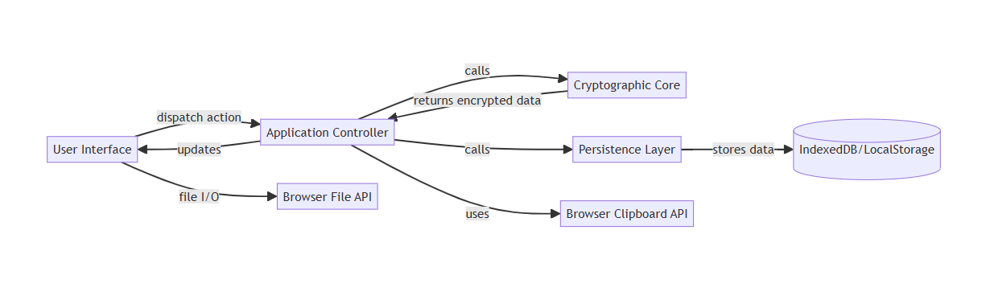
Figure 5.2.2.1 Flowchart of The Components Working Together

5.2.3 System Architecture Design
UniSafe architecture is described in the following two block diagrams: (1) a Layered Component Diagram illustrating the primary modules and their relationships, and (2) a Deployment Diagram illustrating how the modules are within the browser context and communicate with browser-native Web APIs.

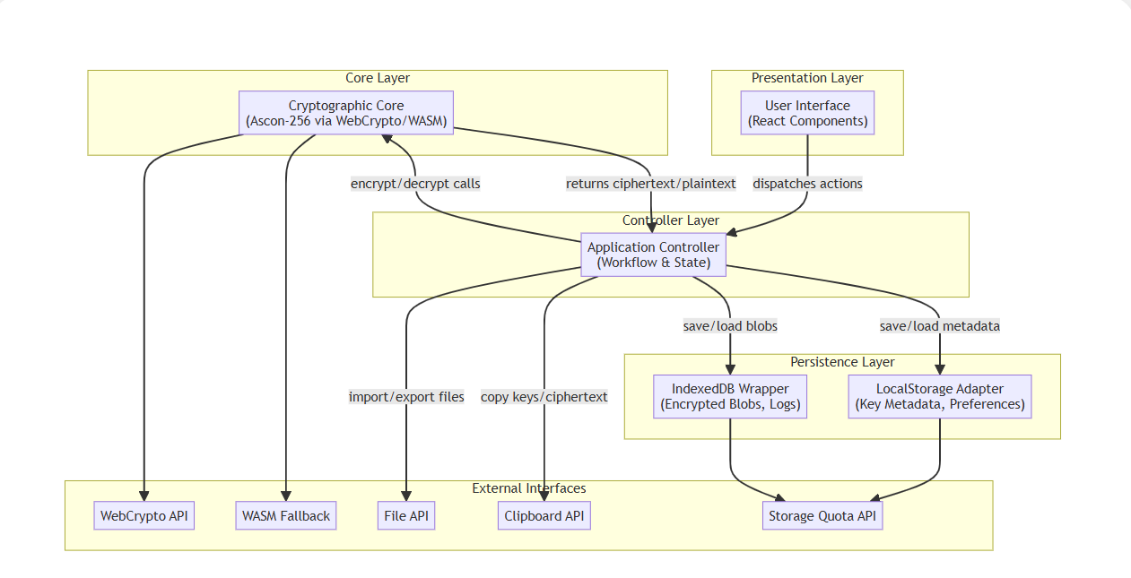
Figure 5.2.3.1 Layered Component Block Diagram

Figure 5.2.3.2 Deployment Block Diagram

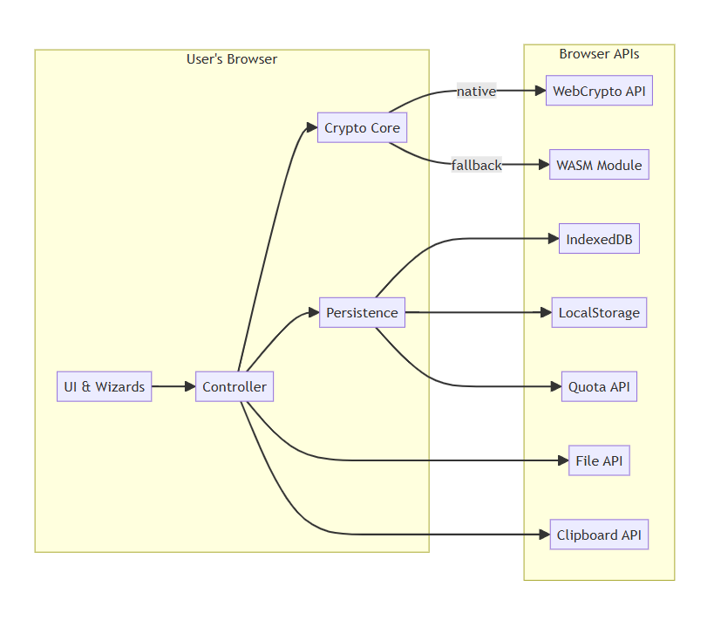

A description of the graph
- The Browser of the user: No external servers are being employed; all the functions are performed on the client-side.
- UI & Wizards: React elements that capture user input and display screens.
- Controller: Main driver that directs processes and app state.
- The Ascon-256 implementation is supported by Crypto Core, which makes calls to WebCrypto or WASM as required.
- Durability: IndexedDB (in case of massive, encrypted data) and Abstracts LocalStorage (on the metadata).
- Browser APIs are the default interfaces to manage quotas, file I/O, storage, clipboard operations, and cryptography.

Together, the diagrams have been used to indicate how UniSafe is internally organised and how the various blocks are related, giving a fast impression of the architecture.

5.3 Data Design
5.3.1 Data Flow Diagram
In the following section, I will mimic a data flow across UniSafe, quoting inputs by the user, the encrypted result, and persistence. To provide a context to demonstrate the system, I will also show a high-level (Level 0) Data Flow Diagram (DFD). It will be preceded by a deeper (Level 1) DFD of the Encrypt File procedure.

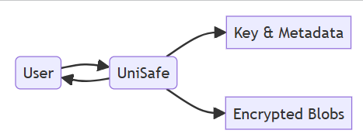

Figure 5.3.1.1 Level 0 DFD

User vs. UniSafe
- The user will direct both in input (as in choosing a file or key to use) and output (in an encrypted file or status messages) to the system as shown by the two-headed arrow between the User and UniSafe.

Key and metadata in UniSafe
- After processing, encryption keys together with any metadata (including label, creation date, or configuration) are either stored or updated to the UniSafe device-local Key & Metadata store.

UniSafe encrypted Blobs
- UniSafe, in turn, stores the actual encrypted information, so-called ciphertext blobs, instead, in its Encrypted Blobs repository. These blobs are a resultant product of the encryption of the files of the user via Ascon-256.
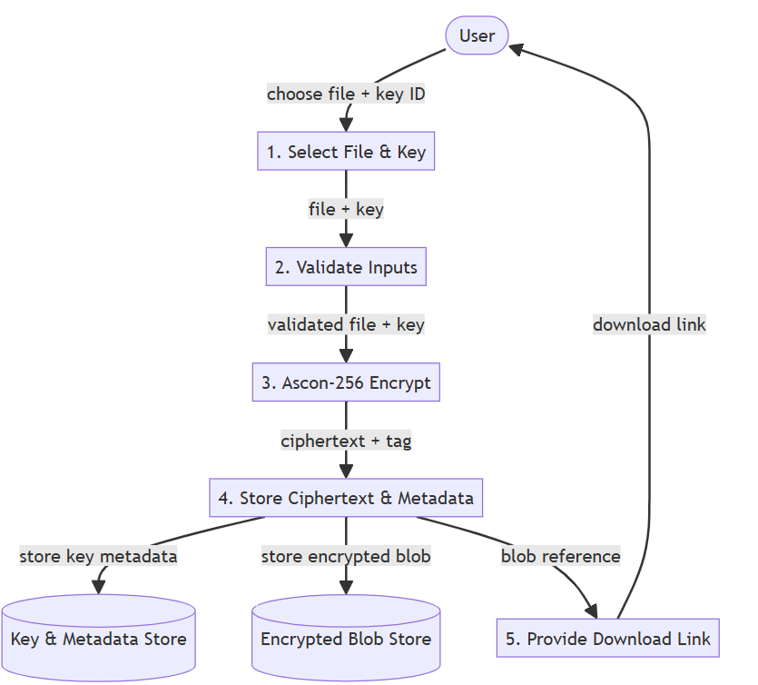

Figure 5.3.1.2 Level 1 DFD

The external entity (user):
- launches the workflows, provides its inputs (files, key selections), and receives output of the workflows (download links, status messages).
Processes (P1-P5):
- Well-marked steps manipulate the data- raw plaintext and key identifiers to encrypted blobs and circumstances.
Data Stores (D1 - D2):
- D1 (Key & Metadata Store): LocalStorage-powered store of key parameters, labels, timestamps, and user preferences.
- D2 (Encrypted Blob Store): Object store, as an indexed DB, that stores binary ciphertext, tags, as well as links to identify references.
Data Flows:
- Movement of data objects between entities, processes, and stores via an arrow shows validations, transformations, and persistence points.

5.3.2 Database Design
The figure will show my ERD diagram of the relationship and entities for my UniSafe database:
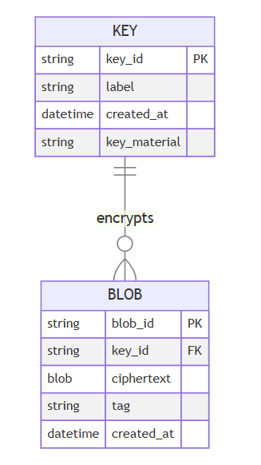

Figure 5.3.2.1 ERD Diagram of the relationship for UniSafe

KEY
- key_id (PK): unique identifier for each encryption key
- label: user-friendly name
- created_at: timestamp of key generation
- key_material: the (encrypted/obfuscated) key bytes
BLOB
- blob_id (PK): unique identifier for each encrypted file
- key_id (FK → KEY.key_id): which key was used
- ciphertext: the encrypted file data
- tag: authentication tag from AEAD
- created_at: timestamp of encryption

How was the data stored and retrieved?
Putting a new blob in storage:
- Create key_id (in case it does not exist) and persist the KEY record on LocalStorage.
- Put user file to encrypt -> generate ciphertext + tag.
- Write a BLOB record to IndexedDB with the attribute name, blob_id, FK key_id, ciphertext, and tag.

Decrypting-retrieve to decrypt:
- Find the BLOB by blob_id in IndexedDB -> retrieve ciphertext + tag + key_id.
- Retrieve the local KEY record using LocalStorage key_id gets key_material.
- On my turn, give CryptoCore.decrypt(ciphertext, key material, tag) and get plaintext back to UI.

5.3.3 Managing System with Data

Section | Aspect | Description
Data Integrity | Authenticated Encryption (AEAD) | Among the uses, Ascon-256 AEAD generates ciphertext + cryptographic tag. Verification is executed on the tag by decryption, just releasing the plaintext.
 | Transactional Storage | IndexEdit writes are atomic; Crashes/interruptions lead to rollback to avoid a corrupted record.
Data Validation | Input Checks | • Files: Must be selected and ≤ 100MB  • Keys: A Valid key ID must be selected  • Metadata: Labels must be non-empty strings; timestamps well-formed
 | UI-Level Guards | Application Controller puts Encrypt/Decrypt buttons in disabled state till Enter is in valid state, no bad API calls.
Data Processing Algorithms | Key Generation | • Uses WebCrypto API or WASM fallback  • Generates 256-bit symmetric keys  • Wrapped with metadata including creation timestamp
 | Encryption / Decryption | • Encrypt: ciphertext, tag = Ascon256.encrypt(plaintext, key, nonce)  • Decrypt: plaintext = Ascon256.decrypt(ciphertext, key, nonce, tag) (tag verification included)
Error Handling & Recovery | Integrity Failures | Detect tag mismatch; show “Data corrupted or wrong key” message
 | Storage Quota Errors | Catch quota limits in IndexedDB/LocalStorage; suggest ways to free up space.

5.4 User Interface Design

Figure 5.4 Minimal UI Design of UniSafe

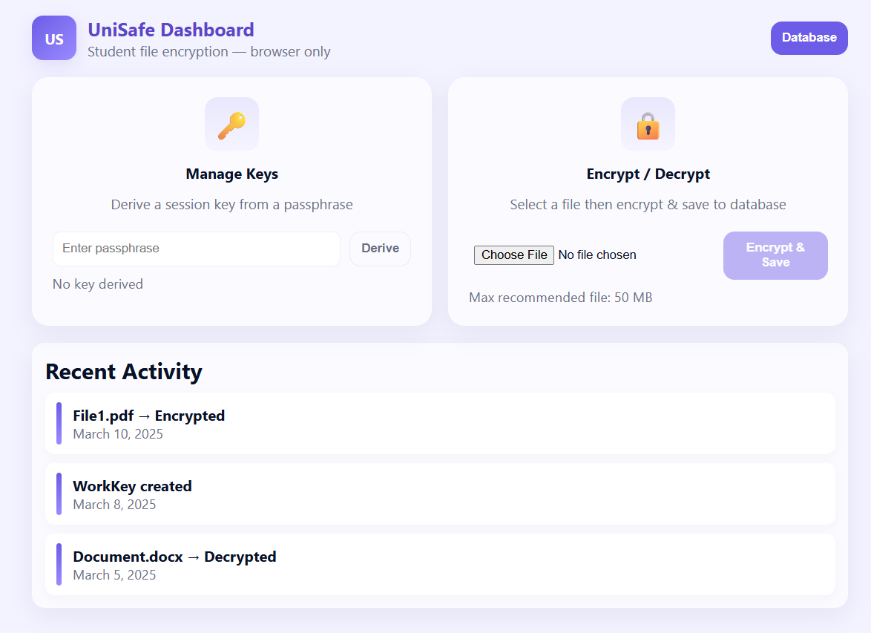

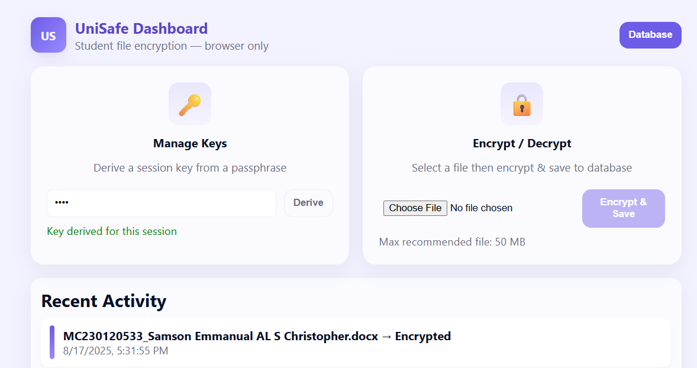

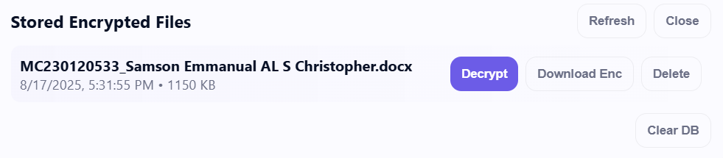

The goal is a visually clean, consistent, one-page dashboard that allows students to retrieve previously encrypted files safely and discover them in the browser (no server), keeps advanced features hidden and out of the way, and makes the two key tasks (Manage Keys, Encrypt/Decrypt) quick to identify.
Ease & Adequacy
- Minimalism Attention: Two big cards put the user in the centre of the activity he/she must perform: Manage Keys and Encrypt / Decrypt. The call-to-action on each card is one thing only (Derive / Encrypt).
- Progressive disclosure: file listing and advanced controls (Refresh / Clear / Download Enc / Delete) are hidden behind the Database drawer so as not to intimidate casual users.

Regularity
- Heading, card, shadows, rounded shapes, and button treatments are consistent across screens- have predictable interaction affordances.
- Mutual iconography (key, lock) gives you semantics immediately.

Acceptance & Cost
- The buttons to perform actions are deactivated until valid inputs are given (e.g., no encrypt until a file is chosen and a key has been derived). This avoids mistakes in use.
- Real-time information: file-size warning, key status text, and activity feed items are informational as to what just occurred and why it occurred.
- Long-running processes present an overlay + spinner to inform the users that the browser is doing something (to prevent clicking again).

Accessibility
- Font size which could be read at 16px and above, and a sensible line-height.
- Dialog, status regions, buttons, and inputs enhanced with ARIA roles and labels; outlines of focused controls (keyboard users) easily get the path.
- Usage of colour variables allows you to adjust contrast to the WCAG level; the sense of status can be expressed semantically (not just colour).

System of Design
- CSS custom variables (colours, radius, shadows) allow theme adjustments (light/dark) to be quick and similar.
- Cards, buttons, and drawers are component-esque: convenient to pull out to a style guide or design system.
IndexedDB (persistent storage on the browser side)
- Is browser native, asynchronous, and has support for blobs and large binary data.
- Works without the internet and survives reloads (per origin).
- There is no server needed -- it matches the 1-page browser needs.

Encryption / key management (the way the demo works)

- User gives passphrase → we derive session key (in demo it is PBKDF2 to AES-GCM).
- Encrypt: Byte representation of the plaintext files in an array buffer, to be encrypted, produce ciphertext, iv, salt, to save the record to IndexedDB.
- Decrypt: user provides passphrase, GPU uses the same salt to derive a key and decrypts ciphertext → download blob is generated.
- In the final system, it should substitute encrypt/decrypt helpers by Ascon/WASM or other primitives of its choice. Keep the same format of metadata (nonce/salt/ciphertext) so that there is no change in the storage code.

5.4.1 Wireframe and Navigation of Flow System
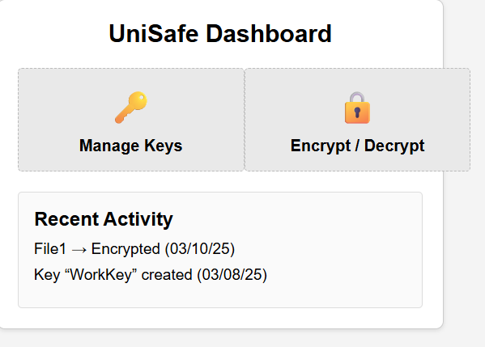

Figure 5.4.1.1 Dashboard of UniSafe
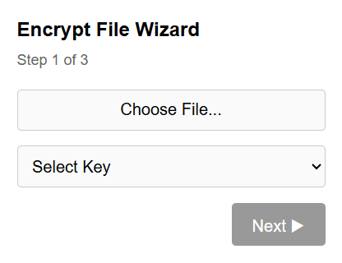

Figure 5.4.1.2 Key management

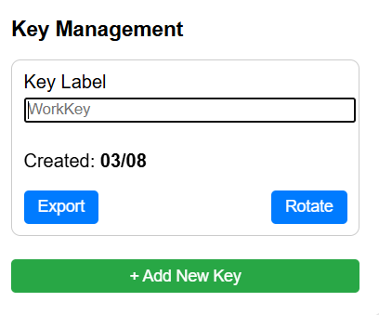

Figure 5.4.1.3 Encrypt/Decrypt Wizard

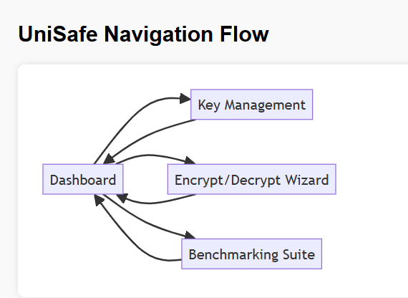

Figure 5.4.1.4 Benchmarking and Navigation Flow of UniSafe

The interface of UniSafe is highly usable, consistent, and clear in simple displays of such functions as management of keys and file encryption. It is visually consistent with its feedback, context-sensitive buttons, input verification in real time, and design. UI is flexible to use on different themes and various devices, and it meets WCAG accessibility requirements. The major exhibits portray these ideals.

5.4.2 Interaction and Feedback System
Interaction | Element | Feedback Mechanism
Form Entry | Text inputs, file picker, dropdowns | Inline validation messages (e.g., “File too large”)
Button Click | Primary/secondary buttons | Ripple effect on click; disabled state when invalid
Errors | Any failure | Modal dialog or inline banner with clear error text
Success | Completed operation | Toast notification (e.g., “File encrypted successfully”)
Confirmation Dialogues | Deleting a key or a large blob prompts | “Are you sure you want to delete the key?” The action cannot be undone

5.5 System Module and Functional Design
5.5.1 Purpose
UniSafe has been designed into six reusable modules, where each module deals with a specific and distinctly understood slice of functionality. I have defined under each module using a flowchart to show its purpose and the role it plays in the system:

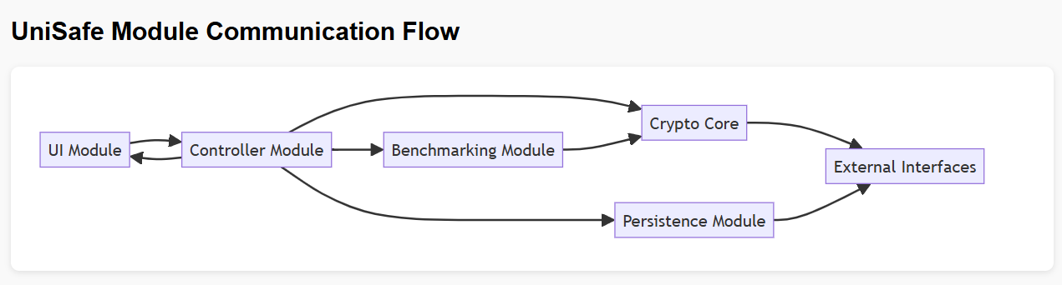
Figure 5.5.1.1 Module Communication Flow of UniSafe

UI Module
- Displays the screens & captures the user actions, then transmits the commands to the Controller.

Controller Module
- Orchestration of workflows: forwards UI requests to the correct service, state & navigation.

Crypto Core
- Implements all cryptographic function (Ascon-256 through WebCrypto/WASM).

Persistence Module
- Stores and receives keys, metadata, and encrypted blobs (LocalStorage & IndexedDB).

Benchmarking Module
- Metrics and reports performance of throughput, latency by calling Crypto Core.

External Interfaces
- Storage, I/O, crypto APIs (Browser APIs: File, Clipboard, Quota, WebCrypto), enabling these.

    - Input/Output
1. Presentation (UI) module
Contributions:
- Form completion, file upload by user (clicks)
- Controller (status, progress) feedback
Results:
- Events in the user interface (selection of a file, clicking a button)
- Form data (Used file or key)
- Navigational minutes

2. Application Controller Module
Contributions:
- UI instances
- Module outputs (storage, benchmark, and crypto)

Results:
- Module requires benchmarking, saving, and encryption
- State changes, success/error updates of the UI

3. Cryptography Core Module 6.3
Contributions:
- Important information
- plaintext or Ciphertext + nonce/tag

Results:
- Ciphertext augmented by tag
- Decrypted plaintext
- Auth mistakes

4. Persistence (Storage)
Contributions:
- Metadata or critically required information
- Encrypted blobs

Results:
- Recuperated blobs and keys
- Operational condition (quota, failure, or success)

Benchmarking module

Contributions:
- Important, iteration number, buffer size

Results:
- Latency, speed (performance indicators)
- A brief discussion of the statistics

6. External Interfaces
Contributions:
1. API requests (quota, clipboard, file I/O, and crypto)
Results:
1. API answers
2. The fallback (WASM) results
3. Confirmations of download/copy

5.5.3 Processes
UI Module: Gather responses to elements and post events and responses.
- Module Controller: Batched verification of input calls to storage, benchmarking, and crypto, update state.

Core Crypto: Generate keys, store nonces and tags, encrypt and decrypt messages, and integrity-check.
Storage Module:
- Save and generate retrievals in LocalStorage; load and save blobs in transactions in IndexedDB.
Benchmarking Module: Calculate mean, median, and standard deviation, bundle the output, execute encrypt/decrypt cycles time-aware.
External Interfaces: Status of report quota; process File API and Clipboard API messages; wrap WebCrypto/WASM.

5.5.4 Interaction Between Modules
- Event flow is UI --> Controller.
- Orchestration; {Crypto Core ↔ Storage ↔ Benchmarking} ↔ Controller
- API Bridge: Crypto Core & Storage uses external Interfaces to make calls to the native browser.
- Feedback Loop: Controller -> UI updates -> The modules issue back problems/ results

5.5.5 Algorithms or Business Logic
- Key Management: Generate/recover/delete keys using UUIDs; make nonces unique per key.
- Encryption Workflow: ciphertext, tag = Ascon256.encrypt(plaintext, key, nonce) to save blob + metadata.
- Decryption Workflow: Get blob using ID; Get key; Check tag before giving out plaintext.
- Benchmark Logic: Fix buffer size: Do N iterations, measure times, and do statistics.
- Validation Rules: Size of the file 100 MB; nonzero strings, and label and required fields to be filled in before the user can take any actions.

5.6 Technology Stack and Tools

5.6.1 List of Technology Stack and Tools Choices
Layer / Concern | Technology / Tool | Rationale
UI Framework | ES6 JavaScript + HTML/CSS | Nimble, browser-bound, no compilation required
Styling | Tailwind CSS | Utility-first, blazing fast UI layout, responsive design
Cryptography | WebCrypto API + WASM Ascon | Safe, easy-to-use browser-based encryption with fallback
Storage | IndexedDB + LocalStorage | Local caching of big files and high-speed metadata access
Testing | Jest | Core logic and modules unit testing, simple unit testing
CI/CD | GitHub Actions | Automates testing and deployment on each commit
Diagrams & Docs | Mermaid.js + Markdown + HTML | Insert graphical illustrations within the documentation
Code Quality | ESLint + Prettier | Neat, uniform, and bug-free program in JavaScript

5.6.2 Infrastructure and Third-Party Integration
Servers, network devices, and specialised equipment are unnecessary since UniSafe entirely runs in the browsing application of the user. Processing, storage (IndexedDB/LocalStorage), and cryptography (WebCrypto/WASM) all happen in the end-user computer. No servers, network equipment, or special gear is required since UniSafe is completely in the user's browser. Processing, storage (IndexedDB/LocalStorage), and all cryptographic operations (WebCrypto/WASM) happen in the computer of the end-user.

5.7 Security Design
5.7.1 Security Overview of UniSafe
To ensure strong data security, UniSafe employs several layers of security. Principally, all files are encrypted and decrypted with the help of the current authenticated encryption method known as Ascon-256 AEAD. This method can ensure the integrity and confidentiality of the data by generating a secure authentication tag together with the ciphertext.
UniSafe offers an avenue to enforce a strict Content Security Policy (CSP) and, in addition, operates on HTTPS to enhance security. This is effective in segregating the program and reduces outside sources of threat since it prevents the execution of unauthorised scripts. Moreover, UniSafe guarantees user privacy as it does not transmit anything to the external network, meaning that the user device never shares his/her personal information with the outside world. All these features, when put together, create a secure, confidential, and trustworthy environment for dealing with delicate information.

5.7.2 Threat and Mitigation
Threat | Mitigation
Cross-Site Scripting (XSS) | Apply CSP, sanitize any user-supplied text, and avoid “innerHTML”
Brute-Force | Encourage strong password derivation if wrapping keys and limit decryption attempts in the UI.

5.8 Scalability and Performance Design
UniSafe, being a client-based program, does not provide any backend servers that are to be expanded. The only thing that would influence its performance and capacity is its CPU, memory, and storage consumed by the user device. Nevertheless, the design allows for expansion in the future, given that it is possible to use cloud backup APIs, where the implementation can offload storage and provide easy cross-device synchronisation. UniSafe utilizes the locking mechanism that is inherent to Indexed DB to regulate multi-tab usage. This ensures that the data is consistent when multiple browser tabs access and work on the same local datastore, and that no conflicts will occur.
Performance-wise, the user interface is maintained as responsive and fluid, with all cryptographic and storage operations executed asynchronously by using Promises or Web Workers. When handling large files, UniSafe tries to reduce the spikes of memory usage during encryption or decryption operations by performing the intended work on data in adjustable chunks. It also stores frequently accessed keys and metadata in memory beyond the initial load, thereby increasing speed as well. Performance is a constant guard against the use of an integrated benchmarking suite. The module mimics real-life conditions, such as encrypting multiple large files simultaneously, and gives performance and latency tests over a spectrum of buffer sizes, 1 KB to 100 MB. Paired with ongoing integration monitoring, these tests provide a safety net for a smooth performance and regression-free operation over the lapse of time.

5.9 Error Handling and Logging Design
5.9.1 Error Handling
An Error Dispatcher Centralised: All asynchronous module calls (Crypto, Storage, Benchmarking) promise (return promises). There is only one handleError(error) function that the Controller deals with rejections.

Classified Exclusions: A validation error is caused by either invalid or absent inputs (e.g., using the wrong key or a file that is too large).
- CryptoError: Encryption/decryption failures (e.g., tag mismatch).
- StorageError: issues with LocalStorage or IndexedDB (quota exceeded, etc).
- SystemError: Runtime unexpected errors.

User Input
- Inline banners should be used to show non-blocking faults, e.g., the kind that reads Label cannot be empty.
- Portal modal dialogues must be used only in case of serious errors (as in this example: Storage quota exceeded - delete old blobs to continue).
- Toast notifications are selected when there is a manageable issue, for example, in case of the problem reported as "Clipboard copy failed, please try again."

A Sporting Recovery: Restore the user-interface state to a conservative safe point and back out any transactions underway on the event of fatal errors (e.g., a malformed blob).

5.9.2 Logging and Monitoring
Client-Side Log Buffer
- A lightweight in-memory ring buffer (e.g., last 100 events) records:
- System Events: transaction commits, module invocation start/end.
- User Behaviour: Clicking of the button, submitting of confidential data-free forms.
- Errors: Exception Type, Stack trace snippet, Timestamp, module context.
Use Cases
- Troubleshooting: Users can export logs to report bugs.

5.10 Deployment Design
The implementation process at UniSafe is automated and optimised for reliability and performance. Static resources, including HTML, JavaScript, and CSS files that are needed by them, are created by executing npm run build in the typical frontend toolchain for the application. GitHub Actions is an added tool used to integrate deployment in a Continuous Integration (CI) process. The process, which encompasses installing dependencies, running unit tests, linting the code to ensure quality of the code, and building the production-ready bundle, is triggered with every push to the main branch. The files are built in the dist./ folder is automatically deployed to a static hosting provider when the build passes all checks. This may encompass anything, such as Netlify, GitHub Pages, or a CDN hosted on Amazon S3. Almost zero-touch, the whole process ensures fast, secure, and repeatable deployments.
The deployment process at UniSafe can be automated and streamlined to be both dependable and efficient. The static assets, including HTML, JavaScript, and CSS files, are created by executing npm run build in the default frontend toolchain of the application. Git Hub installs the deployment into a Continuous Integration (CI) process by using GitHub Actions. This also entails a process that sets up dependencies, runs unit tests and linting to enforce the quality of the code, as well as generating a ready-to-deploy to be deployed bundle with every push to the main branch. The built files are in the dist./ folder will automatically be deployed to a static hosting service when the build is successful. This may also comprise services such as Netlify, GitHub Pages, or an Amazon-supported S3 CDN. There is minimal manual work in the deployment of which the whole process ensures fast, safe, and repeatable deployments.

5.11 Challenges in System Design
IndexedDB quotas, a limitation in browsers, and a lack of threads in JavaScript presented problems to the client-side online application UniSafe. Another, yet another issue – trade between security and convenience. Technical details would be beneficial to the experienced users, whereas regular users would be overwhelmed with information. The client-only architecture offers no key recovery or synchronisation across devices despite the enhanced anonymity.
Finally, time pressures brought the issue of trade-offs to technology decisions that were made. Although WebAssembly fallback to Ascon resulted in better performance in older browsers, it introduced a lot of development and testing overhead. Selecting ES6 in lieu of TypeScript reduced time on initial development but allowed a less wrathful implementation process by virtue of having to work harder not to have type-related bugs.

6.0 References
Compact IEEE-style References (paste into References)
[1] Asana, Agile Methodology, Asana Resources, 2025. [Online]. Available: https://asana.com/resources/agile-methodology. Accessed: May 25, 2024.
[2] A. Sharma, “Enhancing Cloud Security with Next-Generation Firewalls,” eSecurityPlanet, 2021. [Online]. Available: https://www.esecurityplanet.com/products/top-ngfw/. Accessed: May 25, 2024.
[3] MDPI, “Survey on Intrusion Detection Systems Based on Machine Learning Techniques for the Protection of Critical Infrastructure,” Sensors, vol. 23, no. 1, p.13, 2023. [Online]. Available: https://www.mdpi.com/2624-6511/8/1/13. Accessed: May 25, 2024.
[4] National Institute of Standards and Technology (NIST), NIST SP 800-232: Lightweight Cryptography, Gaithersburg, MD: NIST, 2023. [Online]. Available: https://csrc.nist.gov/publications/detail/sp/800-232/final. Accessed: May 25, 2024.
[5] S. Deering and R. Hinden, “Internet Protocol, Version 6 (IPv6) Specification,” IETF RFC 8200, Jul. 2017. [Online]. Available: https://datatracker.ietf.org/doc/html/rfc8200. Accessed: May 25, 2024.
[6] W3C, Web Content Accessibility Guidelines (WCAG) 2.1, W3C Recommendation, Jun. 5, 2018. [Online]. Available: https://www.w3.org/TR/WCAG21/. Accessed: May 25, 2024.
[7] Ascon, “Ascon Family of Lightweight Cryptographic Algorithms,” Ascon.isec.tugraz.at. [Online]. Available: https://ascon.isec.tugraz.at/specification.html. Accessed: May 25, 2024.
[8] W3C, Web Cryptography API, W3C Recommendation, Jan. 26, 2017. [Online]. Available: https://www.w3.org/TR/WebCryptoAPI/. Accessed: May 25, 2024.
[9] W3C, Indexed Database API 2.0, W3C Recommendation, Jan. 5, 2017. [Online]. Available: https://www.w3.org/TR/IndexedDB/. Accessed: May 25, 2024.
[10] W3C, Web Storage, W3C Recommendation, Oct. 29, 2013. [Online]. Available: https://www.w3.org/TR/webstorage/. Accessed: May 25, 2024.
[11] W3C, WebAssembly Core Specification, W3C Recommendation, Dec. 22, 2022. [Online]. Available: https://www.w3.org/TR/wasm-core-1/. Accessed: May 25, 2024.
[12] React, React – A JavaScript library for building user interfaces, React.dev. [Online]. Available: https://react.dev/. Accessed: May 25, 2024.
[13] Jest, Jest – Delightful JavaScript Testing, Jestjs.io. [Online]. Available: https://jestjs.io/. Accessed: May 25, 2024.
[14] Microsoft, Playwright – Fast and reliable end-to-end testing for modern web apps, Playwright.dev. [Online]. Available: https://playwright.dev/. Accessed: May 25, 2024.
[15] GitHub, GitHub Actions, GitHub.com. [Online]. Available: https://github.com/features/actions. Accessed: May 25, 2024.
[16] MkDocs, MkDocs – Project documentation with Markdown, Mkdocs.org. [Online]. Available: https://www.mkdocs.org/. Accessed: May 25, 2024.
[17] Google, Google Forms, Docs.google.com/forms/about. [Online]. Available: https://docs.google.com/forms/about/. Accessed: May 25, 2024.
[18] Netlify, Netlify – The fastest way to build the fastest sites, Netlify.com. [Online]. Available: https://www.netlify.com/. Accessed: May 25, 2024.
[19] Tailwind Labs, Tailwind CSS – A utility-first CSS framework, Tailwindcss.com. [Online]. Available: https://tailwindcss.com/. Accessed: May 25, 2024.
[20] Mermaid, Mermaid – Diagramming and charting tool, Mermaid.js.org. [Online]. Available: https://mermaid.js.org/. Accessed: May 25, 2024.
[21] ESLint, ESLint – Pluggable JavaScript linter, Eslint.org. [Online]. Available: https://eslint.org/. Accessed: May 25, 2024.
[22] Prettier, Prettier – An opinionated code formatter, Prettier.io. [Online]. Available: https://prettier.io/. Accessed: May 25, 2024.
[23] S. Rose, O. Borchert, T. Grance, and N. Bartol, Zero Trust Architecture, NIST Special Publication 800-207, Gaithersburg, MD: NIST, Aug. 2020. [Online]. Available: https://doi.org/10.6028/NIST.SP.800-207. Accessed: May 25, 2024.
[24] K. Beck et al., Manifesto for Agile Software Development, Agilemanifesto.org, 2001. [Online]. Available: https://agilemanifesto.org/. Accessed: May 25, 2024.
[25] T. Reenskaug, MVC (Model-View-Controller), Model-view-controller.org, 1979. [Online]. Available: http://www.model-view-controller.org/. Accessed: May 25, 2024.
[26] Blackbaud, “Blackbaud Resolves Multi-State Attorneys General Investigation of 2020 Security Incident,” Blackbaud Newsroom, Oct. 5, 2023. https://www.blackbaud.com/newsroom/article/blackbaud-resolves-multi-state-attorneys-general-investigation-of-2020-security-incident

